# Title

**A.I. SPORTS IPHONE APPLICATION PROJECT**

**Project Management Plan**



**A.I. Sports**

**1136 E. Harmony Ave**

**Mesa, AZ 85204**

**6/28/2019**

# Table of Contents

Title 1

Table of Contents 2

1. Executive Summary (Placeholder) 6

2. Feasibility (Placeholder) 7

3. Charter 8

4. Stakeholder Register 16

Table 4.1 Stakeholder Register 16

5. Project Scope Statement/Statement of Work (SOW) 17

6. Work Breakdown Structure (WBS) 18

6.1 WBS Diagram 18

Figure 6.1 Work Breakdown Structure (WBS) 18

6.2 Work Breakdown Dictionary (WBD) (Placeholder) 19

Table 6.2 Work Breakdown Dictionary (WBD) 19

7. Project Priority Matrix 19

7.1 Project Priority Matrix 20

Figure 7.1 Project Priority Matrix 20

7.1.1 Constrain 20

7.1.2 Enhance 20

7.1.3 Accept 20

8. Cost Management Plan 21

Table 8.1 Cost Estimating Worksheet 22

8.1 Cost Plan Introduction 22

8.2 Cost Management Approach 22

8.3 Measuring Project Costs 23

8.4 Reporting Format 24

8.5 Cost Variance Response Process 24

8.6 Cost Change Control Process 24

8.7 Project Budget 24

9. Activity On Node (AON) 25

Figure 9.1 Activity on Node Diagram (AON) 25

Table 9.1 Network Information Table 26

10. Risk 27

10.1 Risk Register (Identification) 28

Table 10.1 Risk Register 28

10.2 Risk Breakdown Structure 29

Figure 10.2 Risk Breakdown Dictionary (RBD) 29

10.3 Risk Assessment Matrix 30

Table 10.3 Risk Assessment Matrix 30

10.4 Risk Severity Matrix 31

Table 10.4 Risk Severity Matrix 31

10.5 Risk Response Matrix 32

Table 10.5 Risk Response Matrix 32

10.6 Change Control Process 33

Figure 10.6 Change Control Process 33

10.7 Change Request Form 34

11. Schedule Baselines 35

Figure 11.1 Gantt Chart 35

11.1 Cost/Scope/FTE 36

Table 11.2 Time Phased Budget 36

11.2 Resource Loading and Leveling 36

12. Crash Project (Accelerating Schedules) 37

12.1 Crash Activity M Plan 38

Figure 12.1 Crashed Activity M Graph 38

12.2 Crash Activity C Plan 39

Figure 12.2 Crashed Activity C Graph 39

12.3 Crash Activity H Plan 40

Figure 12.3 Crashed Activity H Graph 40

12.4 Crash Gantt Chart 41

Figure 12.4 Crashed Project Gantt 41

13. Lessons Learned / Best Practices 42

13.1 Introduction 42

13.2 Lessons Learned Approach 42

13.3 Lessons Learned from this Project 42

Table 13.3 Lessons Learned 44

13.4 Lessons Learned Knowledge Base / Database 44

13.5 Lessons Learned Applied from Previous Projects 45

13.6 Process Improvement Recommendations 45

14. Status Reporting (EVA) 46

14.1 Introduction 46

14.2 Scenario 46

14.3 Modified Cost Baseline 47

14.4.1 End of Period 1 Status Report 48

Table 14.4.1 EVA 1 48

14.4.2 End of Period 2 Status Report 49

Table 14.4.2 EVA 2 49

14.4.3 End of Period 3 Status Report 50

Table 14.4.3 EVA 3 50

14.4.4 End of Period 4 Status Report 51

Table 14.4.4 EVA 4 51

14.4.5 End of Period 5 Status Report 52

Table 14.4.5 EVA 5 52

14.4.6 End of Period 6 Status Report 53

Table 14.4.6 EVA 6 53

14.5 Official Status Reporting (EVA) 54

15. Performance Improvement 55

16. Sponsor Acceptance 57

Appendix A. Stakeholder Management Strategy 58

Appendix B. Communication Management Plan 67

Appendix C. Scope Management Plan 83

Appendix D. Schedule Management Plan 94

Appendix E. Risk Management Plan 100

Appendix F. Human Resource Plan 109

Appendix G. Procurement Management Plan 118

Appendix H. Cost Management Plan 130

Appendix I. Integration Management Plan 137

Appendix J. Special Topic 142

# 1. Executive Summary (Placeholder)

The Introduction provides a high-level overview of the project and what is included in this Project Management Plan. This should include a high-level description of the project and describe the projects deliverables and benefits. Excessive detail is not necessary in this section as the other sections of the project plan will include this information. This section should provide a summarized framework of the project and its purpose. Look back at the Project Charter for information to include in this section.

# 2. Feasibility (Placeholder)

# 3. Charter

**Project Charter Plan**

**A.I. SPORTS IPHONE APPLICATION PROJECT**



**A.I. Sports**

**1136 E. Harmony Ave**

**Mesa, AZ 85204**

**6/28/2019**

# Charter Table of Contents

Charter Table of Contents 9

1. Project Purpose/Justification 10

1.1 Business Need/Case 10

1.2 Business Objectives 10

2. Project Description 11

2.1 Project Objectives and Success Criteria 11

2.2 Requirements 11

2.3 Constraints 12

2.4 Assumptions 12

2.5 Preliminary Scope Statement 12

3. Risks 12

4. Project Deliverables 13

5. Summary Milestone Schedule 13

Figure 1.1 Summary Milestone Schedule 13

6. Summary Budget 14

Figure 2. Summary Budget 14

7. Project Approval Requirements 14

8. Project Manager 14

9. Authorization 15

# 1. Project Purpose/Justification

The iPhone Application Project will put A.I. Sports in a league of our own, enabling our partners, investors, and clients access to our real time predictions and recommendations for every sports investment opportunity.

## **1.1 Business Need/Case**

The iPhone application project has been created to disperse real time information and predictions with associated win probabilities efficiently to our partners, investors, and clients for every possible sports investment opportunity. Currently, the process to predict outcomes of sporting events and distribute predictions to our stakeholders is a very slow and manual process. It is time consuming and numerous investment opportunities have been missed because of the time lag. There are also many situations where betting lines and totals on games change and our predictions and associated win probabilities can change dramatically with these changes. We have to restart our entire process each time these changes occur but this project will allow the stakeholder real time access to predictions.

Missed investment opportunities as well as outdated predictions are sent to stakeholders without their knowledge that our predictions are no longer relevant. This new iPhone application will allow users to have the option to manually adjust lines, teams, and “juice” for each and every game. The predictive algorithm will take these changed inputs and output the correct prediction and win probabilities in real time.

## **1.2 Business Objectives**

The business objectives for this project are in direct support of our corporate strategic plan to provide our partners, investors, and clients the best investment strategy in the sports betting market.

* Design and test a new iPhone application within the next 120 days
* Complete distribution of the application to our partners, investors, and clients within the next 180 days
* Reduce the amount of outdated sports investment advice by 75% in the first year

# 2. Project Description

The iPhone Application project will provide a professionally designed mobile phone application to our partners, investors, and clients. The iPhone Application project will utilize state of the art Artificial Intelligence to advise our stakeholders on optimal investment strategies in the sports betting markets. All software and data will be integrated into the company’s current data and IT platforms in order to establish consistency in prediction within the new iPhone Application and our current in-house predictive algorithms.

## **2.1 Project Objectives and Success Criteria**

The objectives which mutually support the milestones and deliverables for this project have been identified. In order to achieve success on the iPhone Application project, the following objectives must be met within the designated time and budget allocations:

* Convert predictive algorithm into Python code and validate performance metrics within the next 15 days.
* Build database tables’ structure specifically for the iPhone Application’s use within the next 15 days.
* Develop data pipeline from disparate data sources to our newly built database tables within the next 30 days.
* Provide specifications for all reporting metrics for use of application and accuracy of prediction model within the next 30 days.
* Wire frame application interface and all pages within the next 60 days.
* Program application to the approved specs and design within the next 120 days.
* Connect application to database within the next 135 days.
* Port Python machine learning algorithm into the application within the next 135 days.
* QA of application within the next 150 days.
* Validation of application’s prediction algorithm within the next 150 days.
* Advertise application to our partners, investors, clients, and potential clients within the next 150 days.
* Test BI reports to ensure every defined KPI is being tracked and reported before application is pushed to production within 165 days.
* Deploy application within the next 180 days.

## **2.2 Requirements**

This project must meet the following list of requirements in order to achieve success.

* The application must pass usability test by our Project Sponsor.
* The application must have the same predictions as our in-house prediction model.
* Application must be productized without disruption to current operations.

Additional requirements may be added as necessary, with project sponsor approval, as the project moves forward.

## **2.3 Constraints**

The following constraints pertain to the iPhone Application project:

* No additional hardware will be purchased for this project.
* All software must be open source and compatible with our current platform.
* Database size must not exceed allotted budget to maintain.

## **2.4 Assumptions**

The following are a list of assumptions. Upon agreement and signature of this document, all parties acknowledge that these assumptions are true and correct:

* This project has the full support of the project sponsor, stakeholders, and all departments.
* The purpose of this project will be communicated throughout the company prior to deployment.
* The Chief Data Scientist will provide additional resources if necessary

## **2.5 Preliminary Scope Statement**

The iPhone Application project will include the design, testing, and delivery of a new mobile application for our partners, investors, and clients. All personnel, hardware, and software resources will be managed by the project team. All project work will be independent of daily and ongoing operations. All project funding will be managed by the project manager up to and including the allocated amounts in this document. Any additional funding requires approval from the project sponsor. This project will conclude when the iPhone application is deployed.

# 3. Risks

The following risks for the iPhone Application project have been identified. The project manager will determine and employ the necessary risk mitigation/avoidance strategies as appropriate to minimize the likelihood of these risks:

* Potential disruption to operations during solution deployment
* External threats by competitors stealing our algorithms
* Clients can more easily distribute our proprietary predictions and investment advice

# 4. Project Deliverables

The following deliverables must be met upon the successful completion of the iPhone Application project. Any changes to these deliverables must be approved by the project sponsor.

* Fully deployed iPhone Application with our prediction algorithm built in

# 5. Summary Milestone Schedule

The project Summary Milestone Schedule is presented below. As requirements are more clearly defined this schedule may be modified. Any changes will be communicated through project status meetings by the project manager.

|  |  |
| --- | --- |
| **Summary Milestone Schedule – List key project milestones relative to project start.** | |
| **Project Milestone** | **Target Date (mm/dd/yyyy)** |
| 1. Project Start | 07/01/2019 |
| * Database built/Algorithm converted to Python | 07/16/2019 |
| 1. Data pipeline built/Reporting KPIs defined | 08/01/2019 |
| 1. Application Wire Frame designed | 09/01/2019 |
| 1. Application code written | 11/01/2019 |
| 1. Connect application to database/Port algorithm into application | 11/16/2019 |
| 1. QA of application/Validation of application algorithm/Marketing campaign deployed | 12/01/2019 |
| 1. QA of reporting KPIs | 12/16/2019 |
| 1. Deploy Application/Project Complete | 01/01/2020 |

## **Figure 5.1 Summary Milestone Schedule**

# 6. Summary Budget

The following table contains a summary budget based on the planned cost components and estimated costs required for successful completion of the project.

|  |  |
| --- | --- |
| **Summary Budget – List component project costs** | |
| **Project Component** | **Component Cost** |
| 1. Personnel Resources | $250,000 |
| * Database Storage | $3,000 |
| 1. Software and Licensing | $15,000 |
| 1. Marketing | $15,000 |
| **Total** | **$283,000** |

## **Figure 6.1 Summary Budget**

# 7. Project Approval Requirements

Success for the iPhone Application project will be achieved when a fully tested mobile application is deployed to our partners, investors, and clients within the time and cost constraints indicated in this charter. Additionally, this measure of success must include a recommendation list for future adaption of an android application as we fully anticipate the necessity of this product to evolve in order to ensure wider adoption. Success will be determined by the Project Sponsor, Mr. Patrick Wolande, who will also authorize completion of the project.

# 8. Project Manager

Amanda Whiting is named Project Manager for the duration of the iPhone Application Project. Mrs. Whiting’s responsibility is to manage all project tasks, scheduling, and communication regarding the iPhone Application project. Her team will include two dedicated IT developers and two dedicated Data Scientists. The rest of her project team will be used in a matrix support implementation pulled from their current functional teams. Mrs. Whiting will coordinate all resource requirements through the department managers. Mrs. Whiting is authorized to approve all budget expenditures up to, and including, the allocated budget amounts. Any additional funding must be requested through the Project Sponsor, Patrick Wolande. Mrs. Whiting will provide weekly updates to the Project Sponsor.

# 9. Authorization

Approved by the Project Sponsor:

Date:

Patrick Wolande

Chief Financial Officer

# 4. Stakeholder Register

The Project Manager, Amanda Whiting, has the overall authority and responsibility for managing and executing this project according to this Project Plan and its Subsidiary Management Plans. The project team will consist of personnel from the Data Science team, Data & Strategy team, IT team, Data Engineering team, Marketing team, Legal team, and Financial team. The project manager will work with all resources to perform project planning. All project and subsidiary management plans will be reviewed and approved by the project sponsor. All funding decisions will also be made by the project sponsor. Any delegation of approval authority to the project manager should be done in writing and be signed by both the project sponsor and project manager.

The project team will be a matrix in that team members from each organization continue to report to their organizational management throughout the duration of the project. The project manager is responsible for communicating with organizational managers on the progress and performance of each project resource.

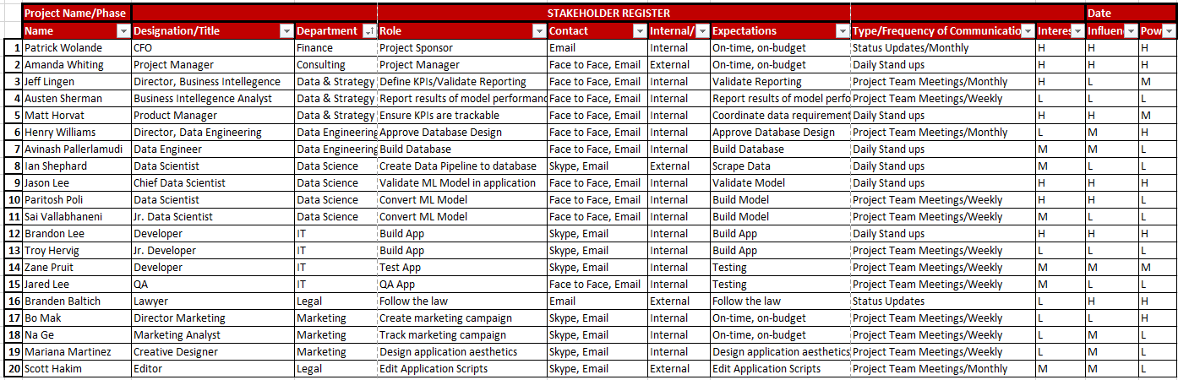

## **Table 4.1 Stakeholder Register**

# 5. Project Scope Statement/Statement of Work (SOW)

This project scope statement sub-plan, found in Appendix C of this document, serves as a baseline document for defining the scope of the iPhone Application Project, project deliverables, work which is needed to accomplish the deliverables, and ensuring a common understanding of the project’s scope among all stakeholders. All project work should occur within the framework of the project scope statement and directly support the project deliverables.

The project scope statement also provides a detailed description of the constraints, exclusions, assumptions, and acceptance criteria. Additionally, the scope statement includes what work should not be performed in order to eliminate any implied but unnecessary work which falls outside the of the project’s scope.

This project includes the design, programming, testing, and delivery of a new iPhone application for distributing A.I. Sports’ official investment advice and prediction with their associated win probabilities for every sports investment opportunity. The deliverables for this project are a completed iPhone application with the functionality for users to have the option to manually adjust lines, teams, and “juice” for each and every sporting event. The predictive algorithm embedded in the application will take these changed inputs and output the correct prediction and win probabilities in real time.

This project will be accepted once the new application has been successfully tested and produces the same results and recommendations as our in-house prediction algorithms. This project does not include ongoing operations and maintenance of the application. Only personnel and resources included in the stakeholder register may be used for this project. Additionally, the project is not to exceed 180 days in duration or $283,000 in spending. Assumptions for this project are that support will be provided by the project sponsor and all department managers and that adequate internal resources are available for the successful completion of this project.

Any changes to the scope statement must be vetted through the approved Project Change Management Process prior to implementation. This completion date for this project is January 1st, 2020.

# 6. Work Breakdown Structure (WBS)

In order to effectively manage the work required to complete this project, it will be subdivided into individual work packages which will not exceed 40 hours of work. This will allow the Project Manager to more effectively manage the project’s scope as the project team works on the tasks necessary for project completion. The project is broken down into six sections: Database, Algorithms, Application, QA (testing), Marketing, and Reporting. Each of these phases is then subdivided further down to work packages which will require no more than 40 hours of work and no less than 4 hours of work (see WBS structure below).

## **6.1 WBS Diagram**

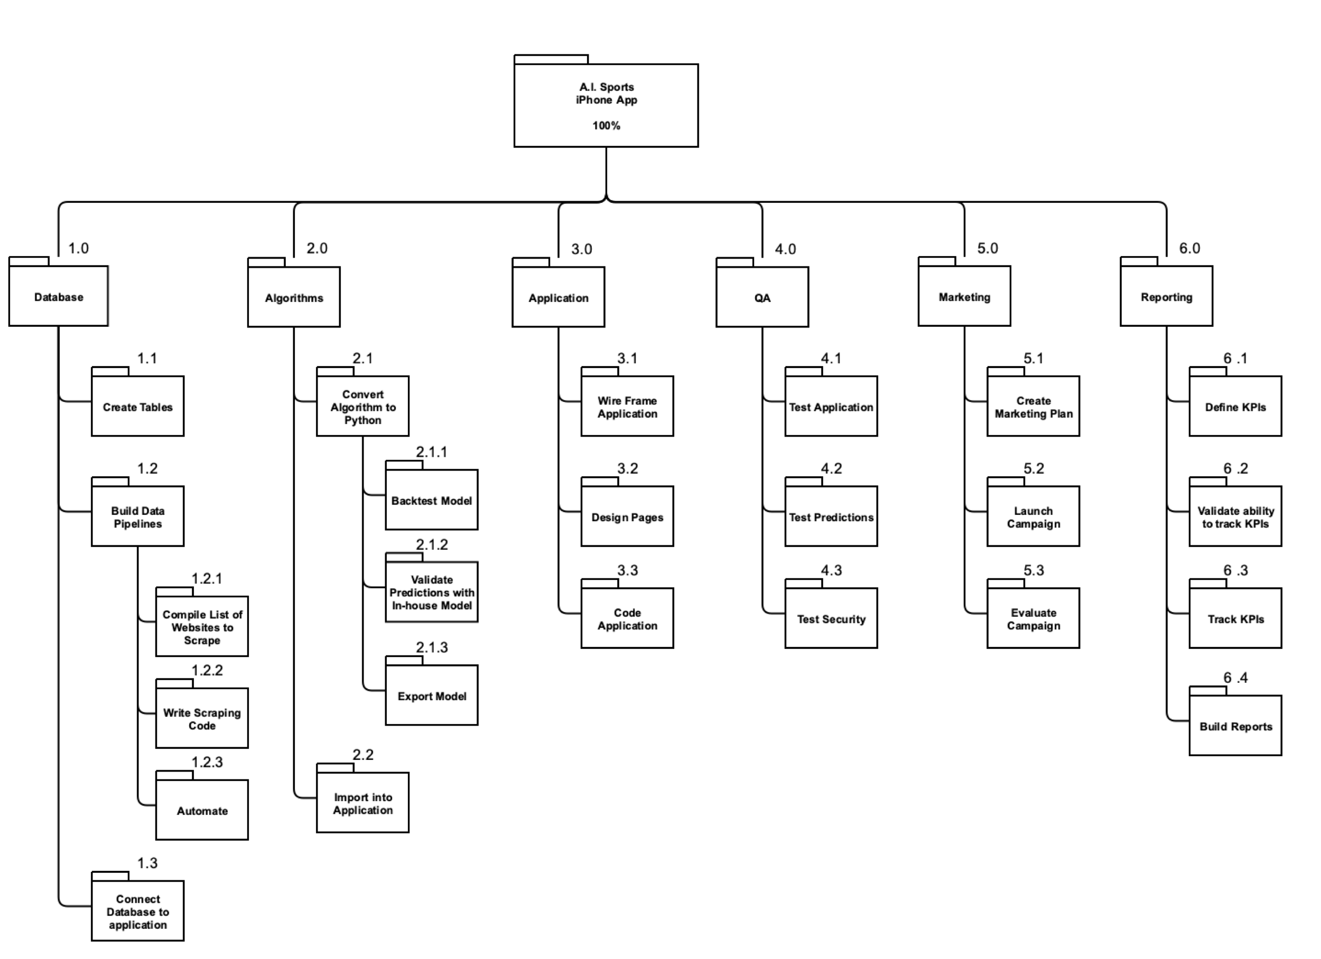

### **Figure 6.1 Work Breakdown Structure (WBS)**

## **6.2 Work Breakdown Dictionary (WBD) (Placeholder)**

In order to more clearly define the work necessary for project completion the WBS Dictionary is used. The WBS Dictionary includes an entry for each WBS element. The WBS Dictionary includes a detailed description of work for each element and the deliverables, budget and resource needs for that element. The project team will use the WBS Dictionary as a statement of work for each WBS element.

|  |  |  |  |  |  |  |
| --- | --- | --- | --- | --- | --- | --- |
| Level | WBS Code | Element Name | Description of Work | Deliverables | Budget | Resources |
|  |  |  |  |  |  |  |
|  |  |  |  |  |  |  |
|  |  |  |  |  |  |  |
|  |  |  |  |  |  |  |
|  |  |  |  |  |  |  |

### **Table 6.2 Work Breakdown Dictionary (WBD)**

# 7. Project Priority Matrix

The iPhone Application Project is operating under a preconceived understanding that projects change over the course of their lifecycle. While the project manager will do everything within her power to strictly follow the project plan, the team has agreed upon specific compromises based on the iPhone Application project’s key priorities. The following details the potential acceptable adjustments.

## **7.1 Project Priority Matrix**

|  |  |  |  |
| --- | --- | --- | --- |
|  | Time | Performance | Cost |
| **Constrain** |  |  | X |
| **Enhance** |  | X |  |
| **Accept** | X |  |  |

### **Figure 7.1 Project Priority Matrix**

### **7.1.1 Constrain**

Constrain by definition is a parameter that is fixed from the onset of the project. Cost will be our constrained priority for the iPhone Application project. A.I. Sports is operating under a tight start-up budget and we do not have the flexibility to go over budget on this project. Cost will be compromised if changes occur.

### **7.1.2 Enhance**

Enhancing the performance of the iPhone Application is something that we will be willing to adjust over the lifecycle of the project. A.I. Sports is trying to bring a new technology to their partners, investors, clients. If there are potential enhancements that can be made to the performance of this technology without adding to the cost, we have the approval and flexibility to make those enhancements.

### **7.1.3 Accept**

A.I. Sports is willing to accept time extensions to finish the iPhone Application project in order to either enhance the performance of the iPhone Application or to save costs. We anticipate this project to adhere to the planned schedule, but we do not have a hard cap deadline for bringing this product to market. A.I. Sports would much rather the project be done without error the first time instead of rushed and need to fix mistakes in updated versions of the application.

# 8. Cost Management Plan

The Cost Management plan for the iPhone Application Project utilized a bottom-up methodology to arrive at our estimations. The project was broken down to the individual work package level to determine the labor costs and total costs needed. The estimated hours of effort needed to properly complete each package were determined by several different strategies. The majority of the work packages have been completed in past projects by these teams and historical data was used to arrive at our estimated hour. Other packages were similar to previous projects and extrapolations were used to reach these estimates. There were a small percentage of packages that were new to our team and an expert was called in to advise on those estimated hours.

The raw hour estimates for each package was then multiplied by 1.33 to reach the estimated duration for the package. This calculation was used to account for the fact that a person will only be able to dedicate roughly two-thirds of their time to this project. The estimated interruption calculation was reached by multiplying the estimated duration by 0.33. The assumption here is that unplanned interruptions or distractions account for a third of a person’s workday. The estimated duration and the estimated interruption times were added together to reach our Total Duration estimate. The calculated labor costs were then determined.

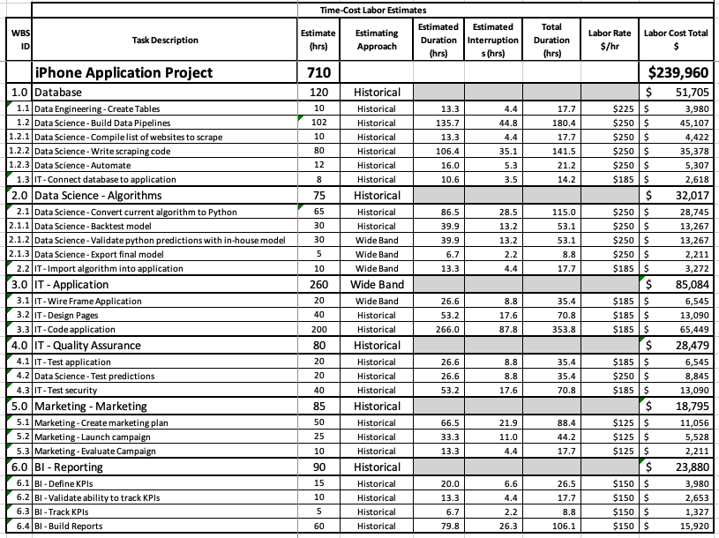

## **Table 8.1 Cost Estimating Worksheet**

## **8.1 Cost Plan Introduction**

The Project Manager will be responsible for managing and reporting on the project’s cost throughout the duration of the project. During the monthly project status meeting, the Project Manager will meet with management to present and review the project’s cost performance for the preceding month. Performance will be measured using earned value. The Project Manager is responsible for accounting for cost deviations and presenting the Project Sponsor with options for getting the project back on budget. The Project Sponsor has the authority to make changes to the project to bring it back within budget.

## **8.2 Cost Management Approach**

Costs for this project will be managed at the fourth level of the Work Breakdown Structure (WBS). Control Accounts (CA) will be created at this level to track costs. Earned Value calculations for the CA’s will measure and manage the financial performance of the project. Although activity cost estimates are detailed in the work packages, the level of accuracy for cost management is at the fourth level of the WBS. Credit for work will be assigned at the work package level. Work started on work packages will grant that work package with 50% credit; whereas, the remaining 50% is credited upon completion of all work defined in that work package. Costs may be rounded to the nearest dollar and work hours rounded to the nearest whole hour.

Cost variances of +/- 0.1 in the cost and schedule performance indexes will change the status of the cost to cautionary; as such, those values will be changed to yellow in the project status reports. Cost variances of +/- 0.2 in the cost and schedule performance indexes will change the status of the cost to an alert stage; as such, those values will be changed to red in the project status reports. This will require corrective action from the Project Manager in order to bring the cost and/or schedule performance indexes below the alert level. Corrective actions will require a project change request and be must approved by the Project Sponsor before it can become within the scope of the project.

## **8.3 Measuring Project Costs**

Performance of the project will be measured using Earned Value Management. The following four Earned Value metrics will be used to measure to projects cost performance:

* Schedule Variance (SV)
* Cost Variance (CV)
* Schedule Performance Index (SPI)
* Cost Performance Index (CPI)

If the Schedule Performance Index or Cost Performance Index has a variance of between 0.1 and 0.2 the Project Manager must report the reason for the exception. If the SPI or CPI has a variance of greater than 0.2 the Project Manager must report the reason for the exception and provide management a detailed corrective plan to bring the projects performance back to acceptable levels.

|  |  |  |
| --- | --- | --- |
| **Performance Measure** | **Yellow** | **Red** |
| Schedule Performance Index (SPI) | Between 0.9 and 0.8 or Between 1.1 and 1.2 | Less Than 0.8 or Greater than 1.2 |
| Cost Performance Index (CPI) | Between 0.9 and 0.8 or Between 1.1 and 1.2 | Less Than 0.8 or Greater than 1.2 |

## **8.4 Reporting Format**

Reporting for cost management will be included in the monthly project status report. The Monthly Project Status Report will include a section labeled, “Cost Management”. This section will contain the Earned Value Metrics identified in the previous section. All cost variances outside of the thresholds identified in this Cost Management Plan will be reported on including any corrective actions which are planned. Change Requests which are triggered based upon project cost overruns will be identified and tracked in this report.

## **8.5 Cost Variance Response Process**

The Control Thresholds for this project is a CPI or SPI of less than 0.8 or greater than 1.2. If the project reaches one of these Control Thresholds a Cost Variance Corrective Action Plan is required. The Project Manager will present the Project Sponsor with options for corrective actions within five business days from when the cost variance is first reported. Within three business days from when the Project Sponsor selects a corrective action option, the Project Manager will present the Project Sponsor with a formal Cost Variance Corrective Action Plan. The Cost Variance Corrective Action Plan will detail the actions necessary to bring the project back within budget and the means by which the effectiveness of the actions in the plan will be measured. Upon acceptance of the Cost Variance Corrective Action Plan it will become a part of the project plan and the project will be updated to reflect the corrective actions.

## **8.6 Cost Change Control Process**

The cost change control process will follow the established project change request process. Approvals for project budget/cost changes must be approved by the project sponsor.

## **8.7 Project Budget**

The budget for this project is detailed below. Costs for this project are presented in various categories -

Fixed Costs: $ 15,000.00

Storage Costs: $ 2,000.00

Labor Costs: $240,000.00

**Total Project Cost $257,000.00**

**Management Reserve $ 10,000.00**

# 9. Activity On Node (AON)



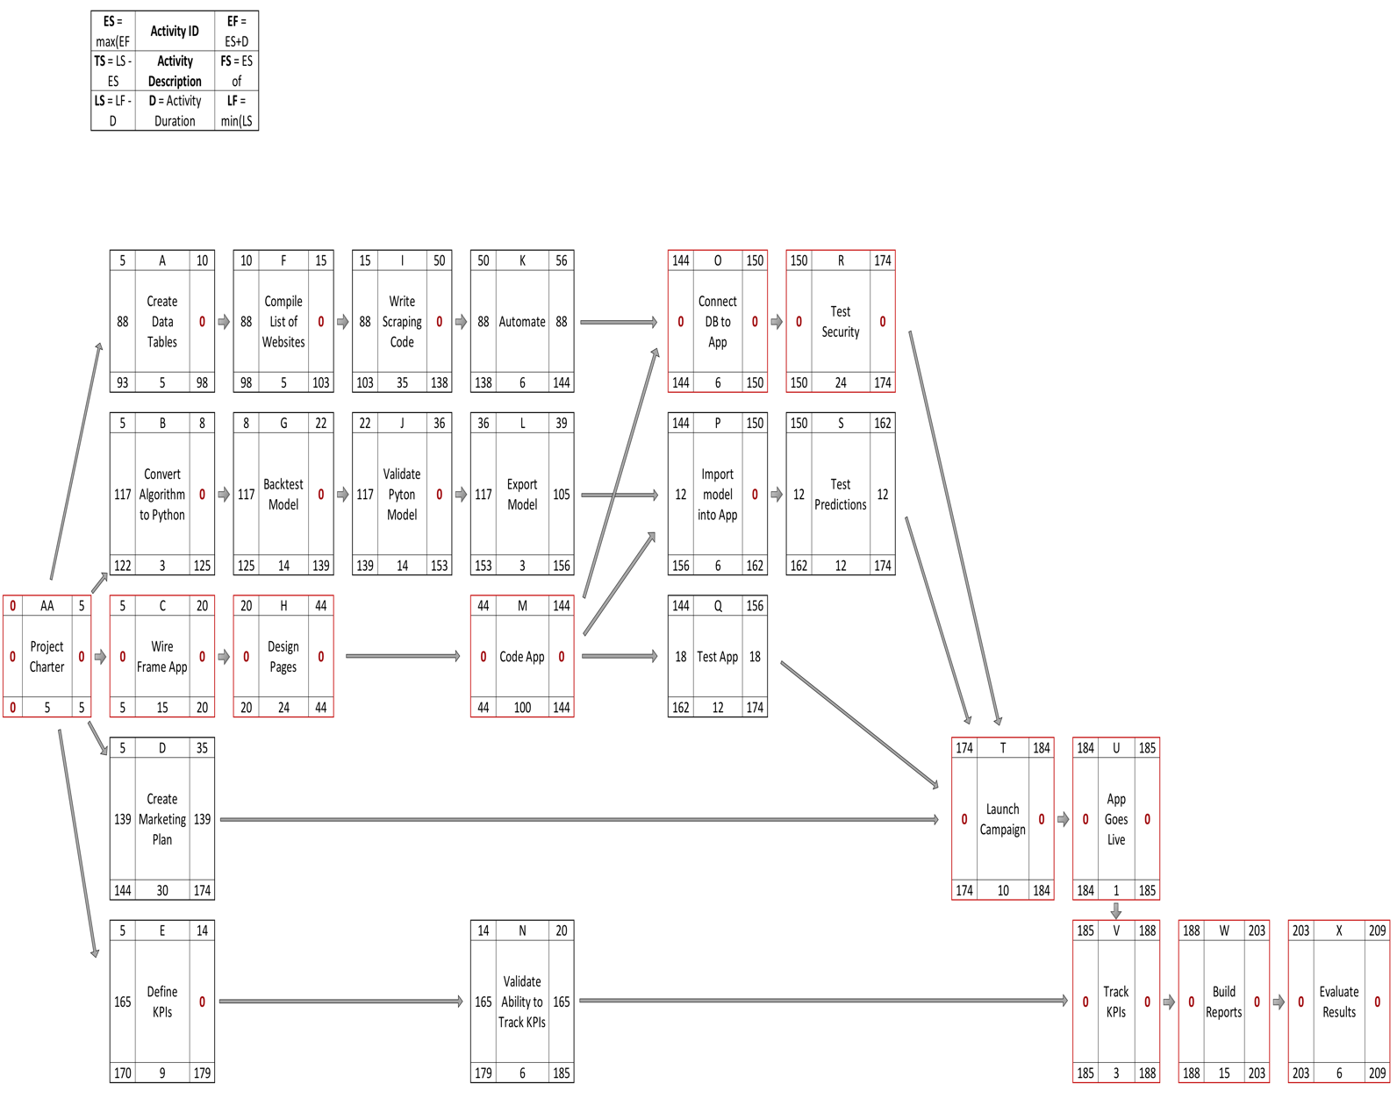

## **Figure 9.1 Activity on Node Diagram (AON)**

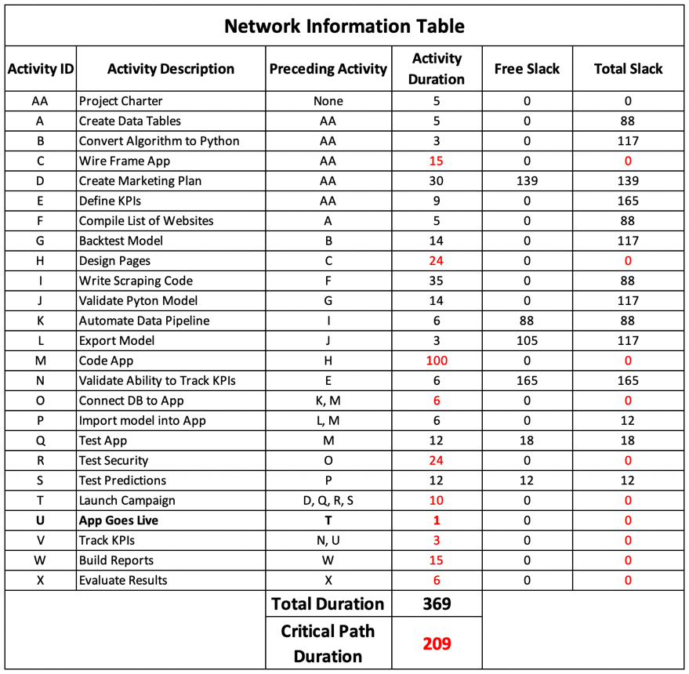

## **Table 9.1 Network Information Table**

There are 24 activities that need to be completed over the span of this project, designated as Activities A through X in the above diagram. The Critical Path through our network, as signified from the red outline in the diagram, begins with Activity AA and progresses through Activity C, H, M, O, R, T, U, V, W, and concludes with Activity X. The total duration along the Critical Path is 209 days. The iPhone Application will go live with Activity U in 185 Days.

# 10. Risk

There are several potential risks associated with this project. We have created a plan to avoid, mitigate, or create contingencies for each potential risk. Most of these risks are controllable, occur within the project timeline, and less severe. However, these are two risks that will only be apparent after the project is complete.

The largest possible risk would be for our competitors to reverse engineer our predictive algorithm. We will do everything within our power to minimize the possible exposure to this risk by withholding over 120 variables in the model. However, our competitors will be able to track the changes to the predictions with changes to the teams, Vegas spreads, and game total inputs. This, coupled with publicly available datasets about each team, will give our competitors a fairly decent idea how our algorithm is built. By holding back as much data as possible and by the way our ensemble model predictions are utilized, we are confident they will never be able to completely replicate our results but there is risk that they will come up with predictions that move the markets against us. This will lower our edge, cutting into our long-term profits.

The other risk after the project is complete comes with giving our clients real-time access to our investment advice. They will be much more likely to share, or distribute, our predictions and advice to others without our consent. This is less severe than having our competitors reverse engineer our algorithm, but it has the same potential severity. If enough people with influence on the markets receive the same investment advice, the edge we have will lessen and our long-term profits will be in danger.

To mitigate as much risk as possible away from this long-term profit threatening risk, we are limiting the iPhone Applications predictions to only spread bets in high liquidity markets. We will not include access to all of our predictions for fringe sports, prop bets, or game totals.

## **10.1 Risk Register (Identification)**



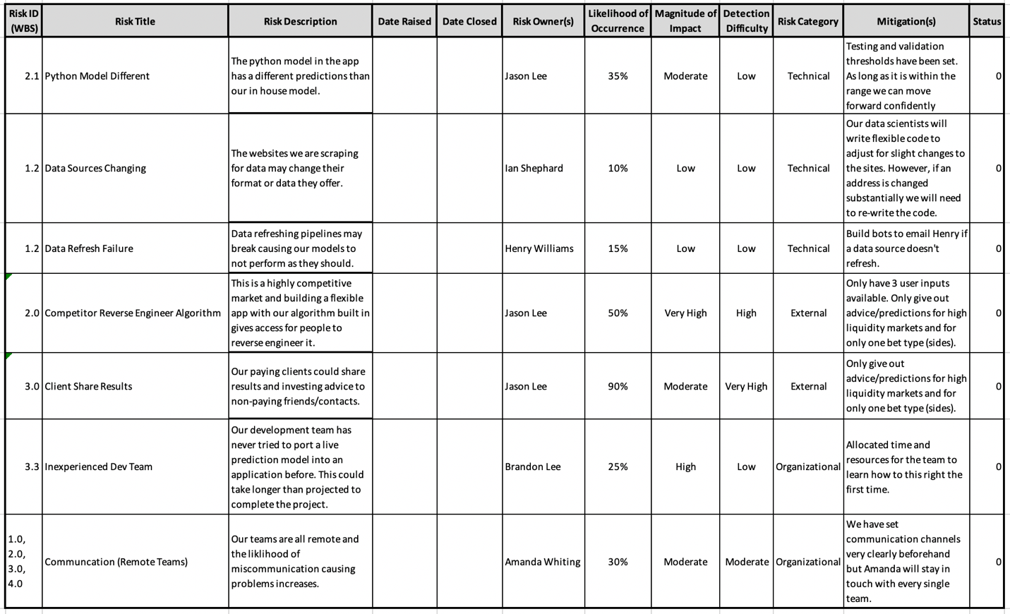

### **Table 10.1 Risk Register**

## **10.2 Risk Breakdown Structure**

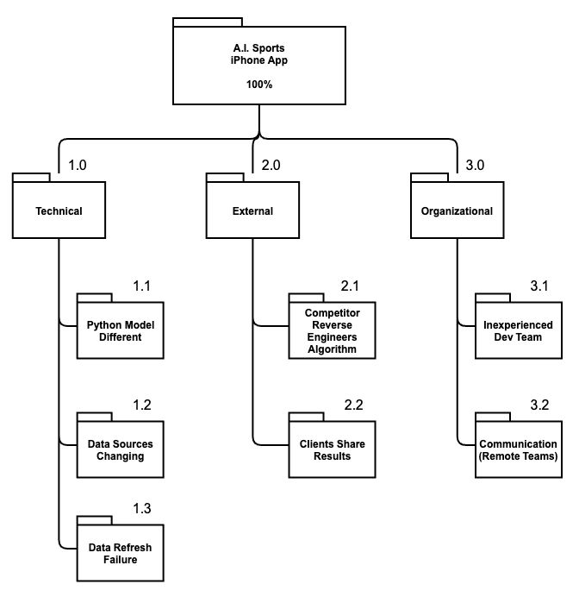

### **Figure 10.2 Risk Breakdown Dictionary (RBD)**

## **10.3 Risk Assessment Matrix**

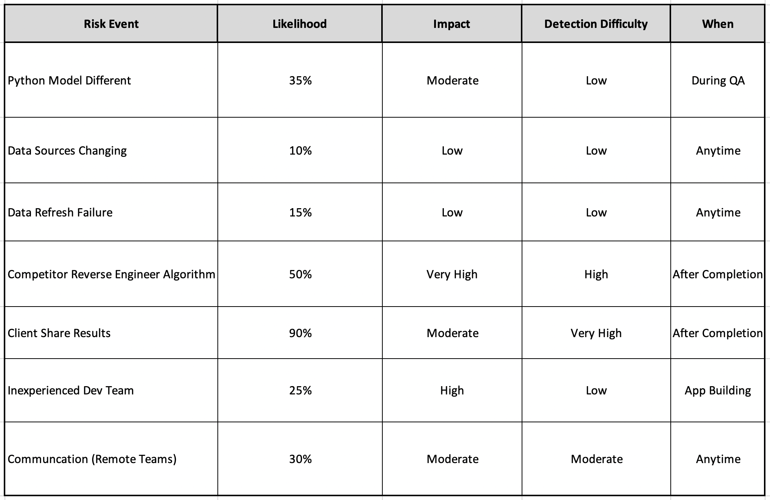

### **Table 10.3 Risk Assessment Matrix**

## **10.4 Risk Severity Matrix**

|  |  |  |  |  |
| --- | --- | --- | --- | --- |
|  | Client Share Results |  |  | Competitor Reverse Engineer Algorithm |
|  |  |  |  |  |
|  |  | Communication (Remote Teams) |  |  |
| Data Refresh Failure |  | Python Model Different |  |  |
| Data Sources Changing |  |  | Inexperienced Dev Team |  |

### **Table 10.4 Risk Severity Matrix**

## **10.5 Risk Response Matrix**

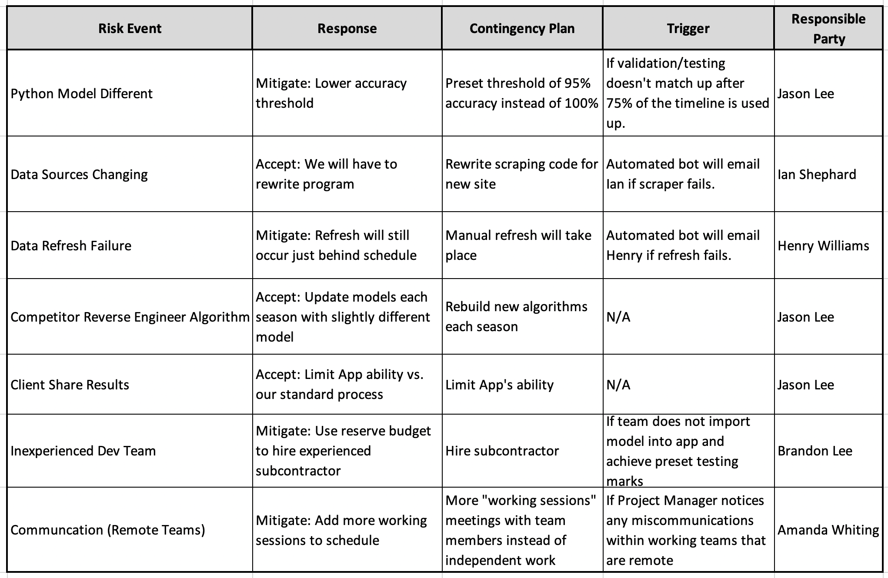

### **Table 10.5 Risk Response Matrix**

## **10.6 Change Control Process**

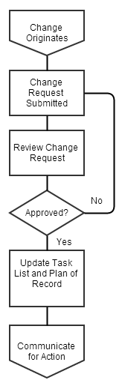

### **Figure 10.6 Change Control Process**

## **10.7 Change Request Form**

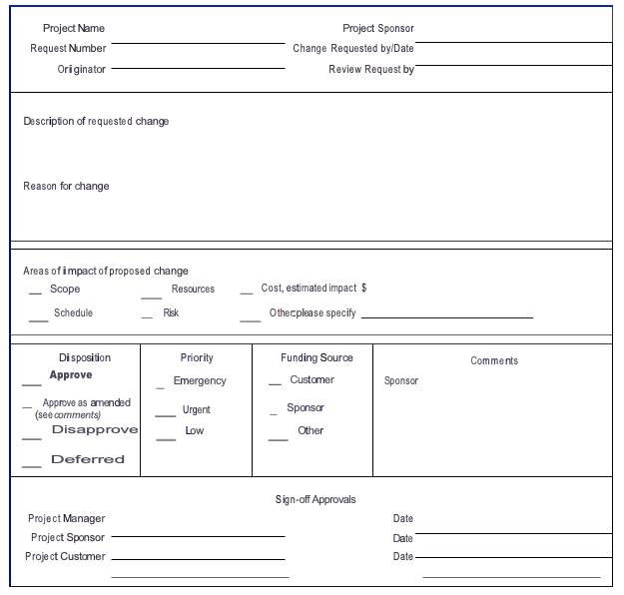

# 11. Schedule Baselines

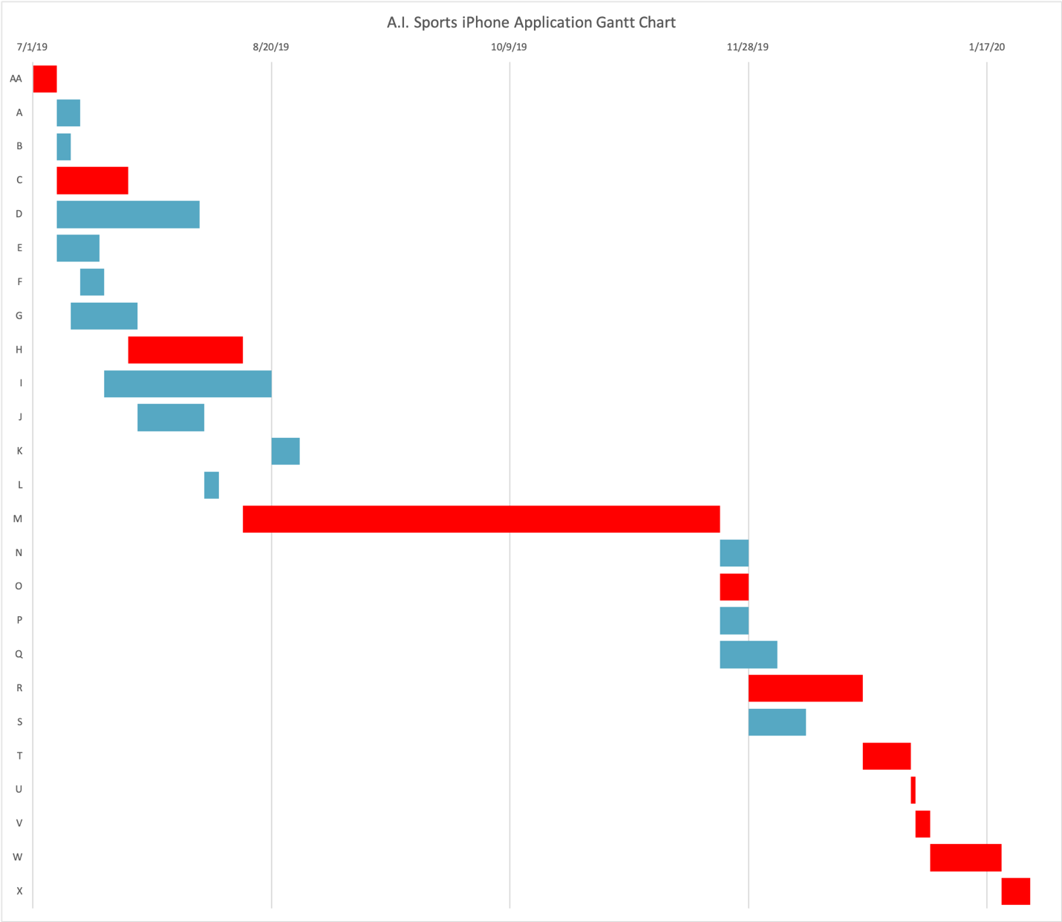

Red = Critical Path

## **Figure 11.1 Gantt Chart**



## **11.1 Cost/Scope/FTE**

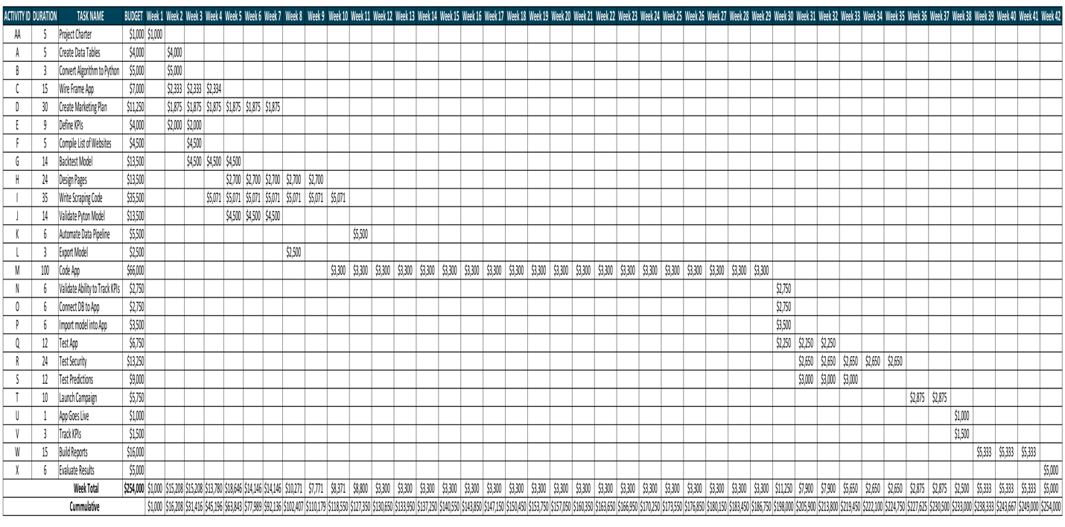

### **Table 11.2 Time Phased Budget**



## **11.2 Resource Loading and Leveling**

The Gantt chart and related spreadsheet (Figure 11.1 above) show the timeline for completion of the iPhone Application project. They take into account the needed resource loading and leveling exercises across all activities.

The iPhone Application project has technical and logical constraints. There are many activities that are sequential in nature and are not capable of parallel processing. There are 5 key network flows by teams that each have sequential tasks. The AON (Figure 9.1) visually depicts these flows. There is a data engineering flow, data scientist flow, developer flow, marketing flow, and business intelligence flow working in parallel. But there are logical steps needed to follow for each flow respectively. The project manager is aware of the steps needed and will hold teams accountable for their deliverables.

The iPhone Application project is also resource constrained. As you can see from the Gantt chart (Figure 11.1 above), Activity M will need 100 days to complete the task because of the lack of resources at the developer position. The best way to substantially accelerate the scheduled delivery time would be to bring in more resources for this task. We could contract out developer positions without causing disruption to any other portion of the project.

The iPhone Application project is not time constrained. We want to ensure the delivery of the best possible product. There is not a hard deadline that we must hit. This does not mean that we want this project to linger on unnecessarily. The project manager will maintain the proposed schedule and adhere to any needed changes that occur which are agreed upon through the proper change request process.

# 12. Crash Project (Accelerating Schedules)

While the iPhone Application project is not time constrained, there may be a need to accelerate the schedule to provide our investors, partners, and clients the product to utilize before the National Football League (NFL) Playoffs begin. This is a high visibility time period for our company and it may be advantageous lining up our product launch with this peak season. The crucial section of the National Basketball Association (NBA) and Nation Hockey League (NHL) seasons fall immediately after this time further incentivizing an earlier project completion date.

The following sections outline the proposed crash plan for several activities that will most effectively accelerate the project timeline without adding unreasonable costs. Each activity lies upon the critical path and will directly impact the project timeline. With these proposed changes taking place, the critical path does not change the order of the activities. It simply shortens the activities mentioned.

## **12.1 Crash Activity M Plan**

There are only 2 available developers available to work on this project. If we were to increase our developer numbers to 4 during Activity M, the resulting project task would be completed in roughly 60 days (saving 40 days). This would increase the cost of the task $13,200 taking it from $66,000 to $79,200. That is a 5.2% increase to our total project budget. However, this may be worth the investment as it would shorten the project by 19% of the projected timeline. The figure below (Figure 12.1) is the crash activity graph showing the change to the project

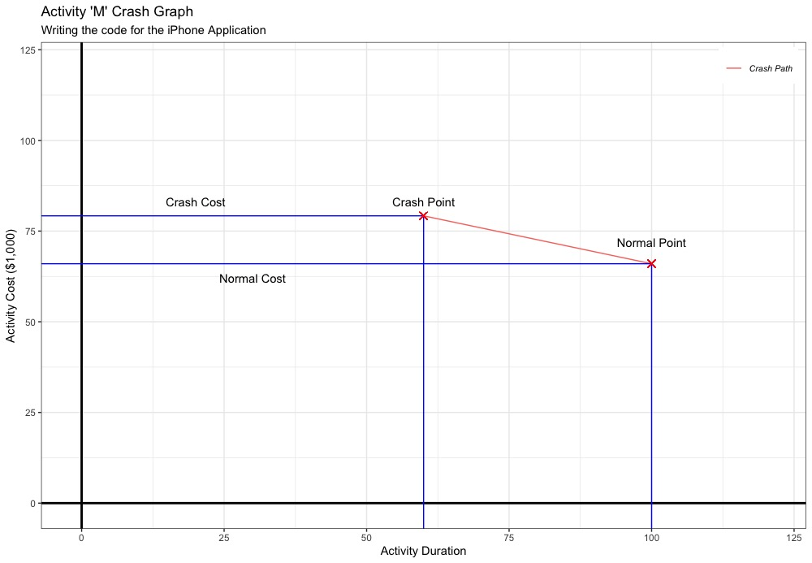

### **Figure 12.1 Crashed Activity M Graph**

## **12.2 Crash Activity C Plan**

If we were to increase the number of available developers for Activity C and H from 2 to 4 our timeline would shrink even more. Activity C is projected to take 15 days, but we will be able to complete it in 10 days with the extra resources. It would cost us an additional $2,333 raising our planned budget of $7,000 to $9,333. This would decrease our total project duration by 2.4% and raise our total budget only 0.92%.

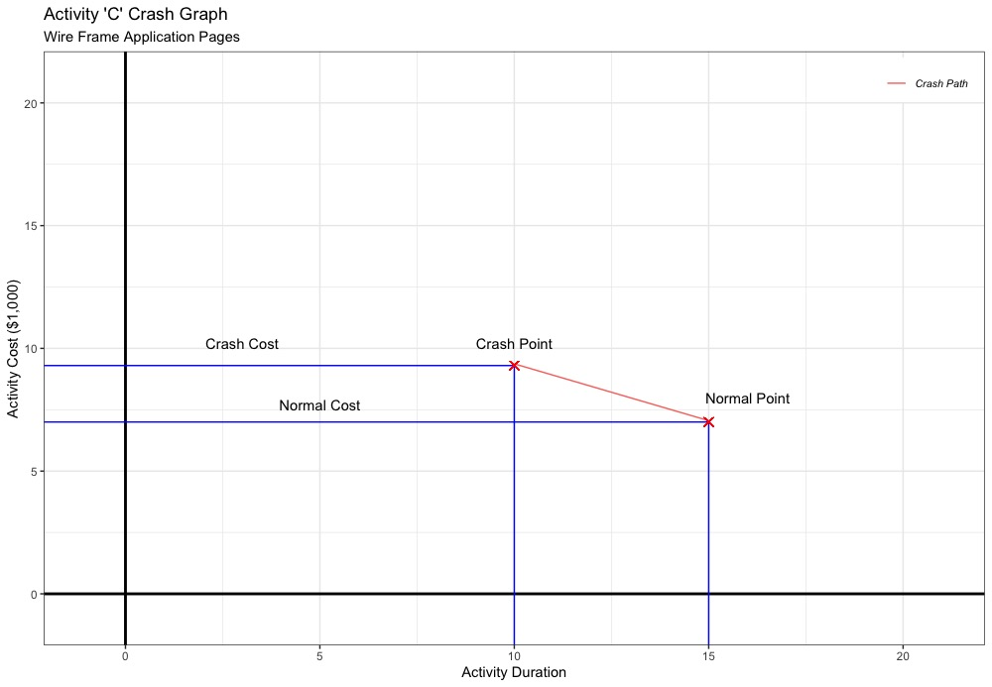

### **Figure 12.2 Crashed Activity C Graph**

## **12.3 Crash Activity H Plan**

The last activity where we could save time by adding the additional developers would be Activity H. Currently, this project is slated to consume 24 days. With the 2 extra developers, we would be able to reduce this time to only 14 days saving us 10 days overall. This would increase our planned budget $2,700 from $13,500 to $16,200.

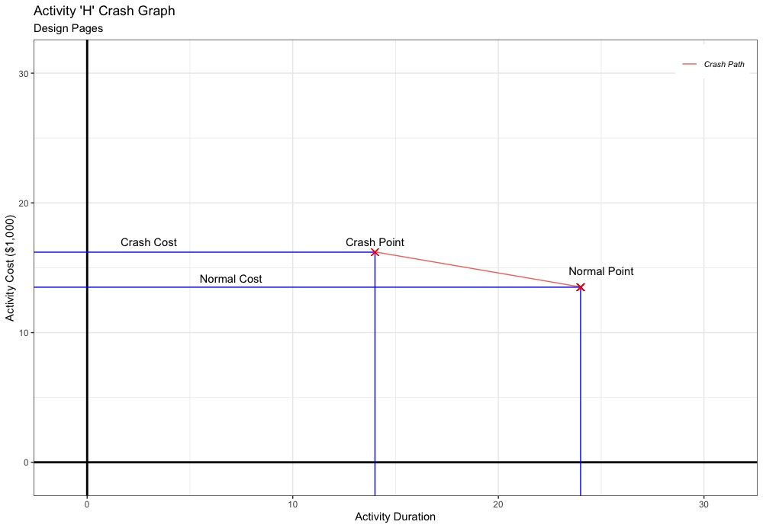

### **Figure 12.3 Crashed Activity H Graph**

## **12.4 Crash Gantt Chart**

In summary, crashing our project by adding 2 additional developers to the 3 Activities (C, H, and M respectively) will save a total of 55 days along the critical path for our project timeline. This crash path would help us reach our changed plan to release the product before the NFL Playoffs. Instead of taking 209 days to complete the project, the iPhone Application project will be completed in 154 days, a 26% reduction. This crash path comes with extra costs. We will need to increase our budget by $18,233. Our initial budget was $254,000 and our crash path budget would be $272,233. This amounts to a 7% increase. Figure 12.4 is an updated Gantt chart reflecting all the changes on the total project. The left side is the current schedule and the chart on the right is the crashed project timeline.

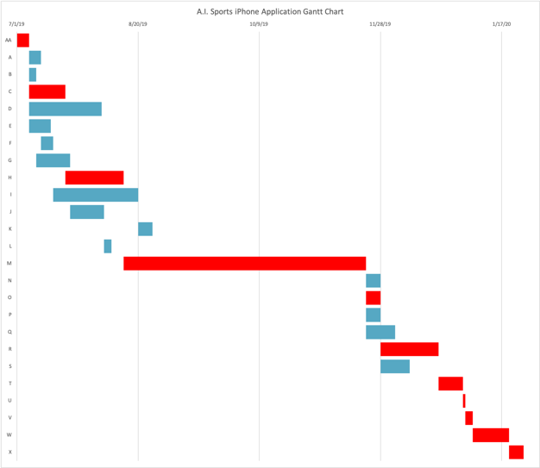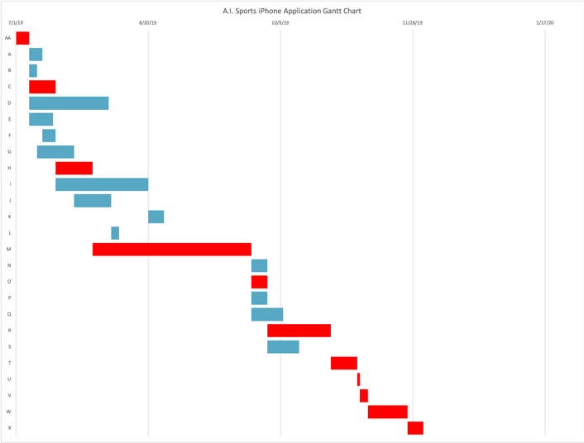

### **Figure 12.4 Crashed Project Gantt**

# 13. Lessons Learned / Best Practices

## **13.1 Introduction**

The purpose of the lessons learned document for the iPhone Application Project is to capture the project’s lessons learned in a formal document for use by other project managers on similar future projects. This document may be used as part of new project planning for similar projects in order to determine what problems occurred and how those problems were handled and may be avoided in the future. Additionally, this document details what went well with the project and why, so that other project managers may capitalize on these actions. Project managers may also use this document to determine who the project team members were in order to solicit feedback for planning their projects in the future. This document will be formally communicated with the organization and will become a part of the organizational assets and archives.

## **13.2 Lessons Learned Approach**

The lessons learned from the iPhone Application Project are compiled from project journal entries throughout the project lifecycle. Lessons learned were also gathered from both realized and unrealized risks in the project risk register as well as through interviews with project team members and other stakeholders as necessary. The lessons learned from this project are to be used as references for future projects and contain an adequate level of detail so that other project managers may have enough information on which to help base their project plans. The lessons learned in this document are categorized by project knowledge area. These knowledge areas consist of: communications management, human resource management, cost management, scope management, and time management.

## **13.3 Lessons Learned from this Project**

The following chart lists the lessons learned for the iPhone Application project. These lessons are categorized by project knowledge area and descriptions, impacts, and recommendations are provided for consideration on similar future new mobile application or web application projects. It is important to note that not only failures or shortcomings are included but successes as well.

|  |  |  |  |  |
| --- | --- | --- | --- | --- |
| Category | Issue Name | Problem/Success | Impact | Recommendation |
| Communication Management | Communication between teams | The marketing and BI teams felt siloed. While a team communication plan was followed, the engineering and data science teams continued to work closely together excluding the other teams. | There was discontent created in the team with certain people not feeling motivated to complete the project. | PM must strive to include everyone and try to make everyone feel included and valued on the them. |
| Human Resources Management | Values Awards | There were 5 value awards handed out at the completion of the project. | These value awards, although not monetary, helped increase unity with the team as the value awards were voted on by the team members. | This was a great tool to help the team come together after a long project. Highly recommend implementing something similar to this in future projects. |
| Cost Management | Exceeded Budget | Project timeline acceleration was agreed upon and costs were increased. However, they were increased more than expected and the project exceeded the budget. | The project sponsor was frustrated with the final cost of the project. He is less likely to agree to proposed changes in the future. | The PM needs to be able to accurately account for budget changes. |
| Scope Management | Scope Creep | Stakeholders thought of additional features to add to the project throughout the project lifecycle. However, the PM was able to keep them at bay following preset change process and the project maintained the original scope. | The stakeholders felt they were above the proposed scope change process and didn’t follow protocol. The PM was able to show great leadership skills by diplomatically and respectfully holding the stakeholder to the same standards as everyone else. | The PM must have agreed upon scope change protocols to ensure scope creep does not negatively impact the project. This also helps maintain relationships in the team. |
| Human Resources Management | Incentive plan | There was a need to increase the timeline however there were no incentives offered to team members. | The team is highly motivated by incentives and the timeline could have been accelerated without adding more resources if there were proper incentives. | Have incentives based on early completion of specific milestones. |

### **Table 13.3 Lessons Learned**

## **13.4 Lessons Learned Knowledge Base / Database**

The lessons learned for the iPhone Application Project will be contained in the organizational lessons learned knowledge base maintained by the project management office (PMO). This information will be cataloged under the project’s year (2019) and the type of project (Mobile Application/Web Application) for future reference. This information will be valuable for any project manager assigned to a mobile or web application project in the future.

## **13.5 Lessons Learned Applied from Previous Projects**

The iPhone Application Project utilized several lessons learned from past projects:

1. The addition of a priority matrix using constraint, enhance, and accept was necessary because previous project had complications and concessions were needed to be made. Having a priority matrix setup at the onset of a project will help a PM know which areas of the project can be adjusted as the project moves forward and complications arise.
2. The inclusion of a risk mitigation plan with regards to data sources changes was added because of a previous predictive modeling project from 2016. There was a change in the data sources and set back the project many weeks redoing work. We have adjusted by creating our own database and saving each day’s datasets.

## **13.6 Process Improvement Recommendations**

As indicated in the lessons learned chart above, the iPhone Application Project did not have a process for accurately adjusting on the fly with cost adjustments when accelerating the project. Not only is this a lesson learned for similar future projects; but the organization must ensure that all project managers are aware of the need for this process to be included in the planning of all future projects.

There is potential to improve project team motivation and accelerate project timeline by adding specific milestone incentives of the monetary variety. Therefore, it is recommended that prior to work beginning on any new project, the project manager should lay out milestones and incentives associated with reaching those milestones.

# 14. Status Reporting (EVA)

## **14.1 Introduction**

The iPhone Application project utilizes the project management tool of Earned Value Analysis to provide weekly status reports to stakeholders and the project sponsor. An Earned Value Analysis (EVA) includes several key metrics that help track variations from planned to actual costs and scheduling over the length of the project. The EVA lists each task and shows a completion percentage for each one. It also includes Earned Value (EV), Actual Costs (AC), Planned Value (PV), Cost Variance (CV), Schedule Variance (SV), Cost Performance Index (CPI), and Schedule Performance Index (SPI). When there are variations, we are able to create a revised estimated cost at completion (EAC).

* Earned Value = Completion Percentage / Planned Value
* Cost Variance = Earned Value – Actual Cost
* Schedule Variance = Earned Value – Planned Value
* Cost Performance Index = Earned Value / Actual Cost
* Schedule Performance Index = Earned Value / Planned Value
* Revised Estimated Cost at Completion = (Work Remaining / CPI ) + Actual Cost

## **14.2 Scenario**

There will be a disturbance to the planned project. During Task C (Wire Framing of the application pages), the developers run into issues. They find that the planned transitional pages do not make logical sense. They need to regroup with the project manager and stakeholder to see if they can shrink the total number of pages by combining two stakeholder requirements onto the same page. This extends the timeline of the project by a full week. This delay occurs along the critical path, extending the entire project delivery time by a week and increasing the cost.

There will also be complications with Task G (Backtesting the newly created predictive algorithm). We had anticipated a possibly that the new model may not perform as well as our in-house model but there was substantial degradation to our new results. This task does not lie on the critical path, but the costs will increase trying to solve the problem with the new model.

## **14.3 Modified Cost Baseline**

Current cost baselines can be found in section 11.1 of this project management plan. These are the modified cost baselines with the handful of disturbances applied over the entirety of the project. The project will be extended by two weeks and an increase of $14,033. The spreadsheet below contains the detailed time phase budget with the modified adjustments.



**14.4 Period 1-7 Weekly Progress Emails**

The project manager of the iPhone Application project will provide the project sponsor a weekly Earned Value Analysis table to keep him appraised of the progress of the project. These serve as a first notice of any potential issues or deviations from planned timelines and budgeting. The following is the first 6 periods of status communication between the project manager and the project sponsor.



Status completion tables.

(periods 1-7)

### **14.4.1 End of Period 1 Status Report**

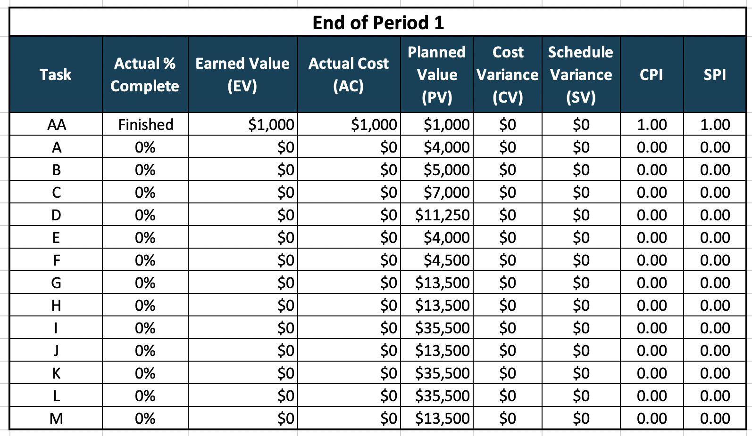

### **Table 14.4.1 EVA 1**

Patrick,

The iPhone Application kicked off this week. Everything is progressing as planned. We completed the project Charter and will be starting up 5 separate tasks on Monday. The data engineers will begin creating the database. The data scientists will be start converting over our predictive models into a workable form for the mobile app. The marketing team will brain storm their plan and the business intelligence team will start defining our key performance indicators. The developers will start drawing up what the actual application will look like. We’re all very excited about this project! If you have any questions just let me know.

Thanks,

Amanda

Project Manager, A.I. Sports

### **14.4.2 End of Period 2 Status Report**

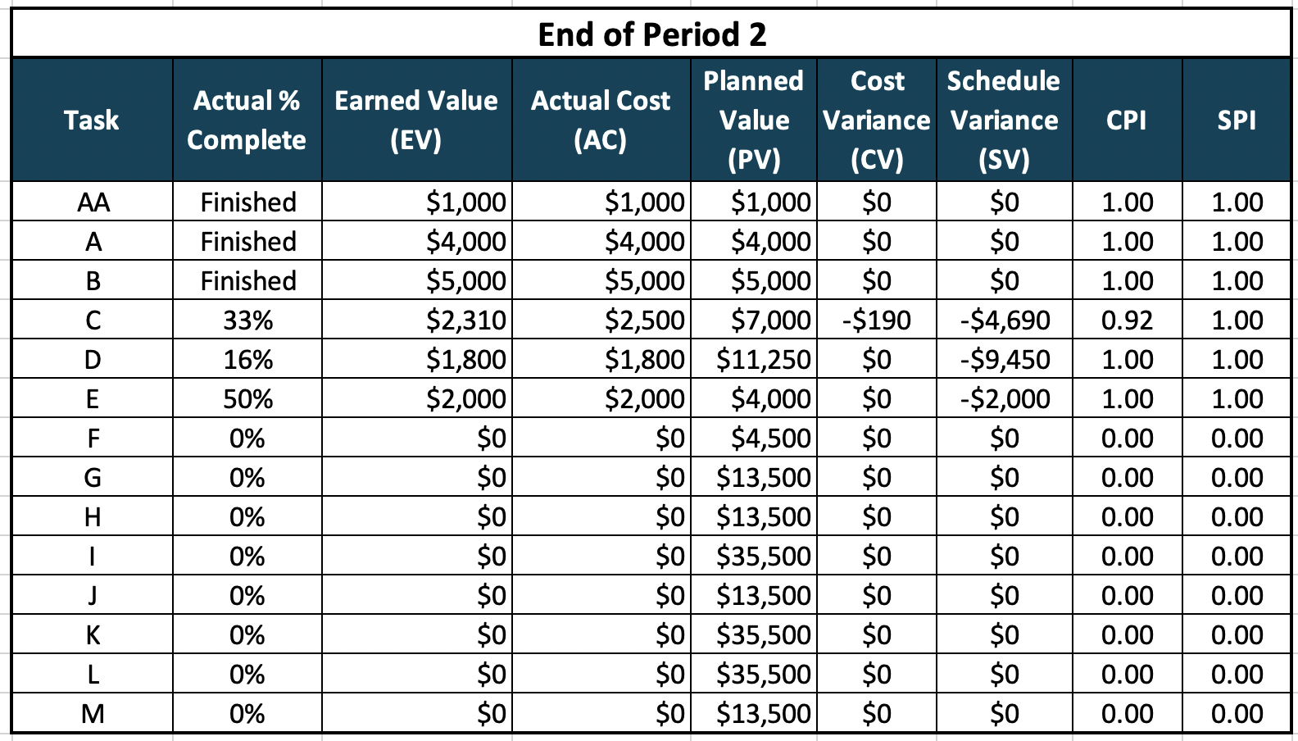

### **Table 14.4.2 EVA 2**

Patrick,

The iPhone Application just completed its second week. We have made great progress. We have completed 3 tasks so far. The data engineers completed the database structure and are moving onto their next task. The data science team was able to convert the predictive algorithm over to python in preparation for importing into the application.

Unfortunately, our developers are running just a tad behind schedule with their wireframing of the application pages. They are currently $190 over budget. I will keep you informed on anything that we can do to help get us back on track. Updated estimate cost at completion (EAC) for their task is $7,575. If you have any questions, please reach out to me.

Thanks,

Amanda

Project Manager, A.I. Sports

### **14.4.3 End of Period 3 Status Report**

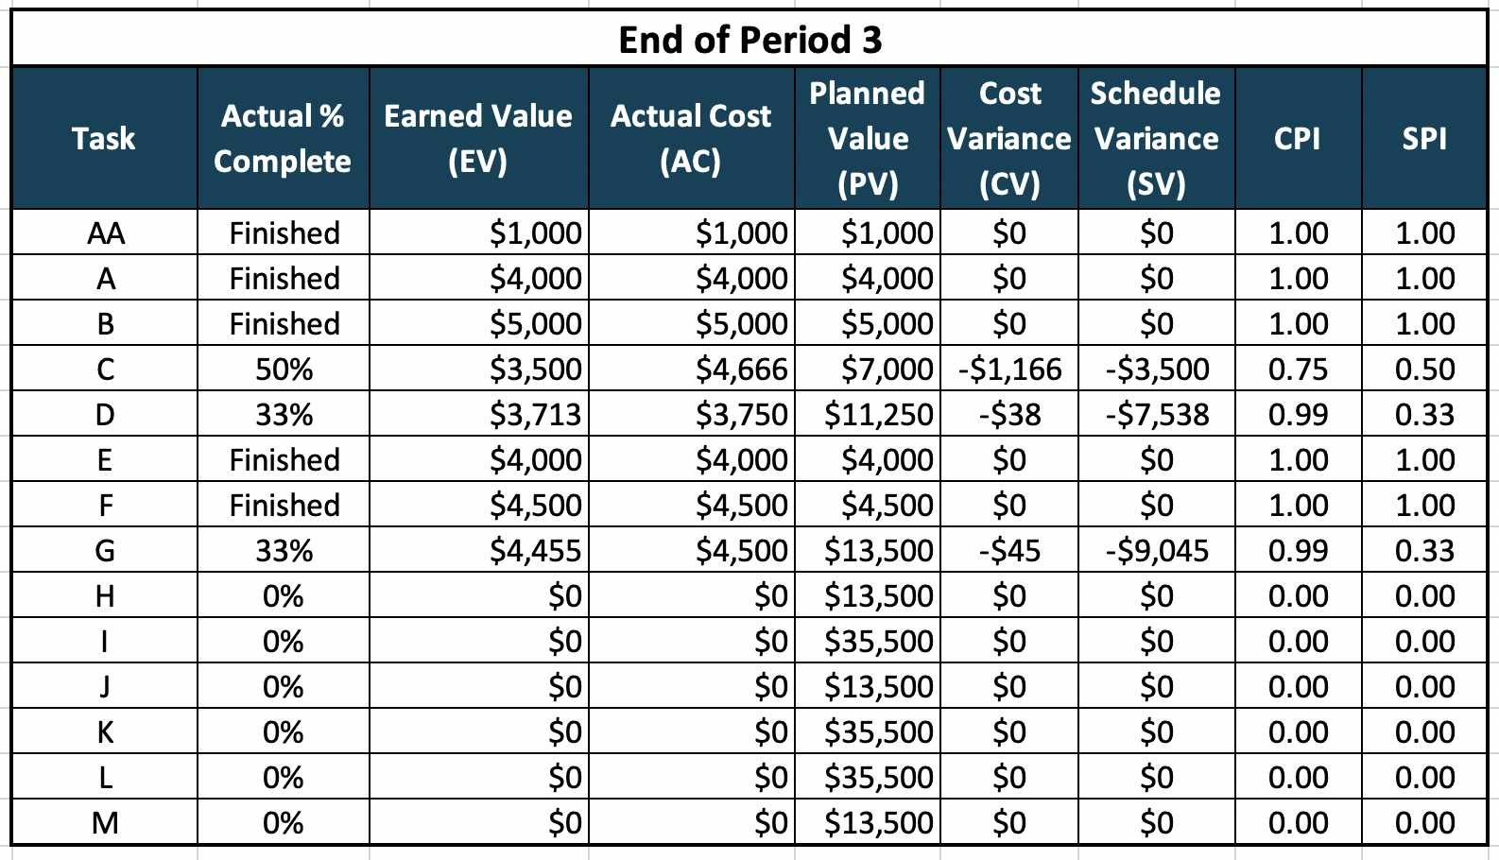

### **Table 14.4.3 EVA 3**

Patrick,

The iPhone Application just completed its third week. We completed an additional two tasks over the week. The BI team has clearly defined all of the KPIs for the project and the list of websites that need to be scraped for data has been compiled.

Task C has fallen even farther behind schedule. The developers provided feedback that some of the requirements needed for the application are logistically problematic. We need to follow change protocol to decrease the total number of pages by combining two stakeholder requirements onto the same page. The updated estimate cost at completion (EAC) for this task is now $9,333. This task is on the critical path and will push back the overall project timeline by two weeks. If there are any questions just let me know.

Thanks,

Amanda

Project Manager, A.I. Sports

### **14.4.4 End of Period 4 Status Report**

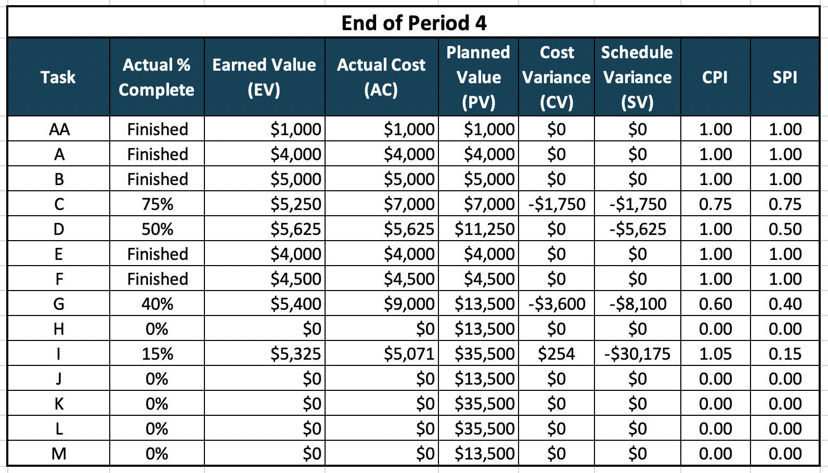

### **Table 14.4.4 EVA 4**

Patrick,

The iPhone Application just completed its fourth week. The marketing team is on pace and halfway through their task. We had anticipated a possibly that the data science team may run into a problem with their new model. However, there was substantial degradation to our new model when compared to our in-house model. This task does not lie on the critical path, but the costs will increase trying to solve the problem. The revised estimate cost at completion (EAC) for task G is now $22,500.

Task C has progressed as we expected from our adjusted timeline. The approved change request made it through and the team is working on the augmented plan. There is no change to the updated estimate cost at completion (EAC) for this task. It remains $9,333. If there are any questions just let me know.

Thanks,

Amanda

Project Manager, A.I. Sports

### **14.4.5 End of Period 5 Status Report**

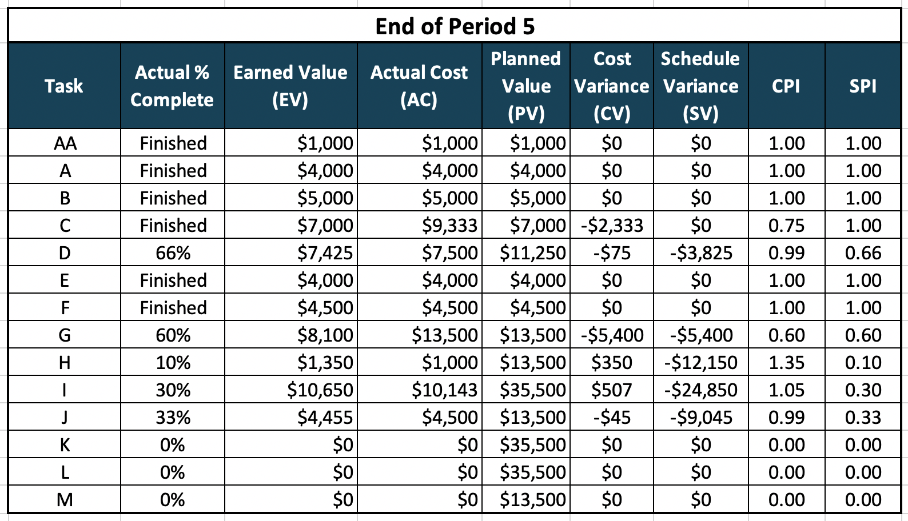

### **Table 14.4.5 EVA 5**

Patrick,

The iPhone Application just completed its fifth week. I’m happy to report that task C has been completed at our revised projected cost of $9,333. We are still two weeks behind schedule overall. We currently have five tasks in progress and six tasks completed in our first five weeks at work.

The developers are working ahead of pace on task H to try and make up a little time from task C. Task G is on track with our revised estimates. All of the other tasks are on pace with our planned estimates. If there are any questions just let me know.

Thanks,

Amanda

Project Manager, A.I. Sports

### **14.4.6 End of Period 6 Status Report**

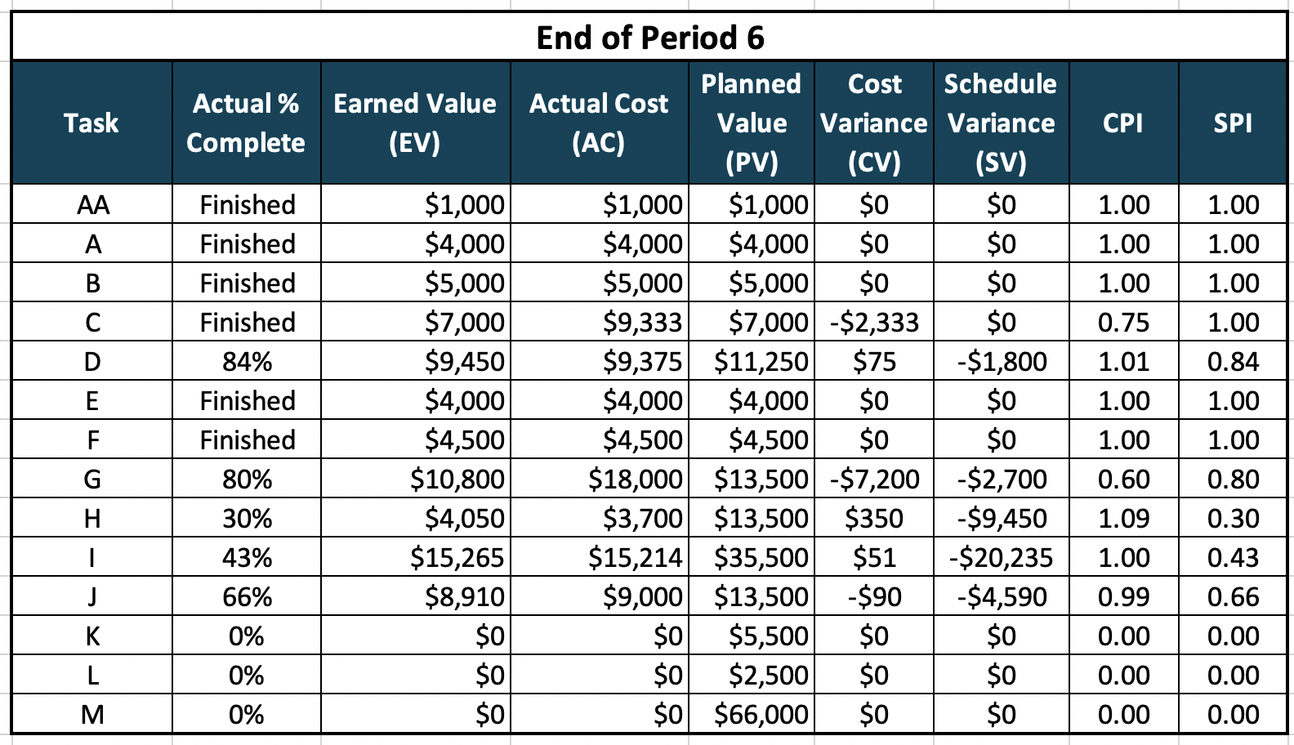

### **Table 14.4.6 EVA 6**

Patrick,

The iPhone Application just completed its sixth week. I’m happy to report that there are no hiccups during this week. All five of our in-progress tasks have remained on pace. If there are any questions just let me know.

Thanks,

Amanda

Project Manager, A.I. Sports

## **14.5 Official Status Reporting (EVA)**

The project manager of the iPhone Application project will provide the project sponsor a periodic Earned Value Analysis Report. This report is more in-depth than the weekly progress emails.

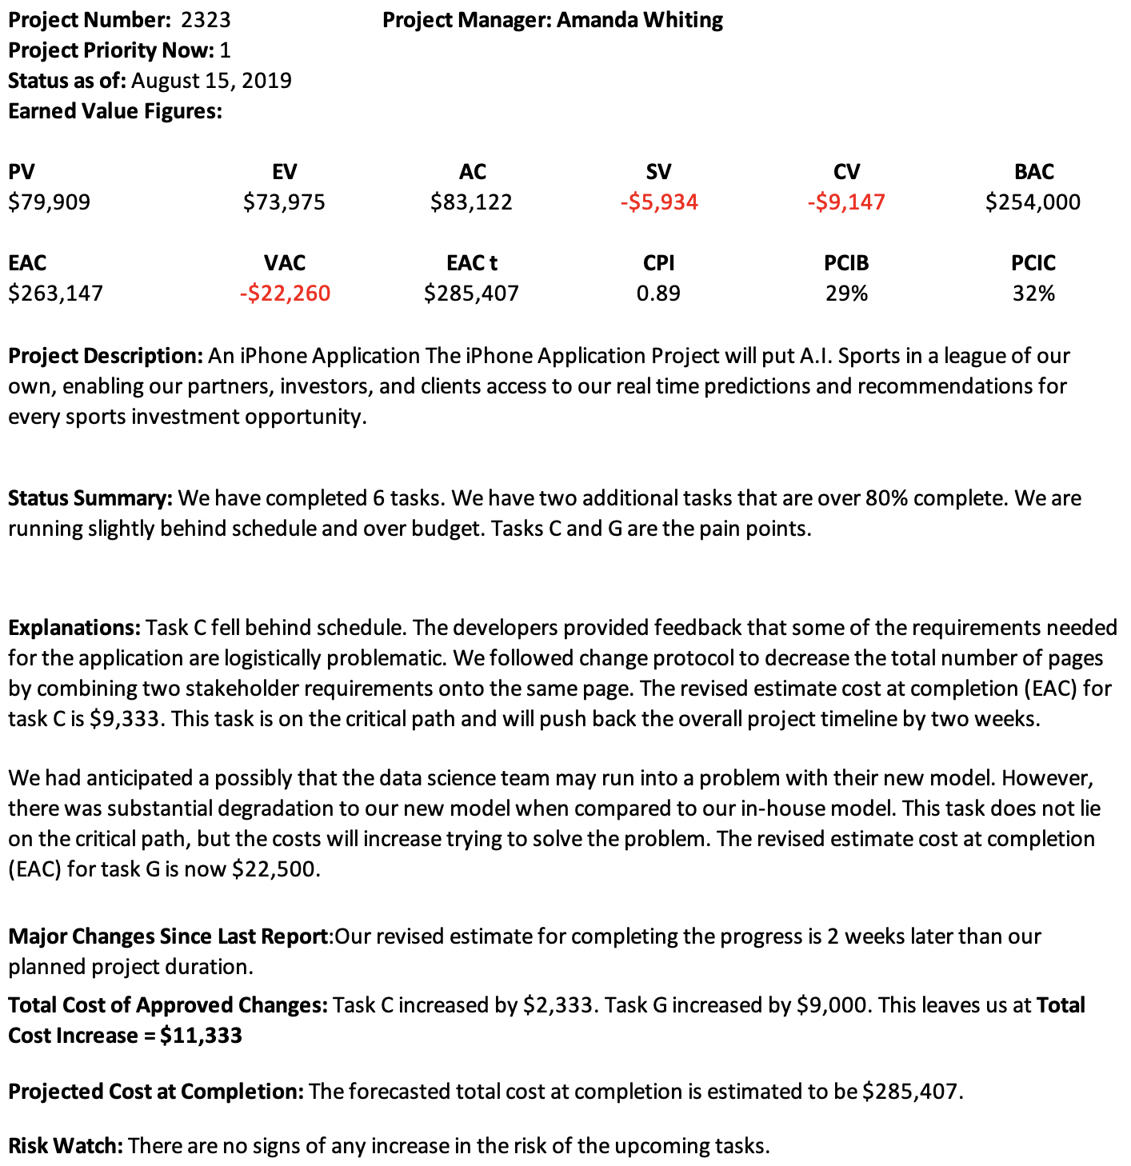

# 15. Performance Improvement

Mr. Big Cheese,

I appreciate the opportunity to assess your current situation. My team knows that this is an extremely important decision that you need to make regarding this next project. We know that you have made sweeping changes within your organization because of the failures of the past and the eyes of the world are all on you and your company’s next steps.

My team has spent substantial time investigating the previous failed projects within your organization and have found key areas to watch out for. We have also identified small effort, high impact points for improvement. We know that you cannot afford to have another catastrophic failure. This next project is a make or break project for ABC’s future.

The “Widget in Space” project is an exciting project that has the potential to truly generate exponential returns and plenty of positive media exposure if executed properly.

My team has performed an extremely invasive background check on this “Paul Stephenson” who you are considering heading up this pivotal project. Young hot shots tend to live fast and free. Their mindset is typically a high-risk high reward mentality. At this point in your company’s lifecycle, you may be needing to lean more towards low risk avenues. Luckily, we did not find any serious red flags in his past that would give us pause.

From our deep analysis, we came to the conclusion that the previous projects where Paul earned his recognition overachieved by situation and not entirely by process. In other words, roughly 45% of his success can be attributed to luck or influences outside of his control. His value over a replacement project manager was negligible for many projects.

With that said, we do feel there are many positives that he brings to the table. His coworkers have only positive remarks about his knowledge and leadership skills. His charisma and enthusiasm have helped get the most out of the people he works with. He delivers excellent final products that far exceed all the projections. He adapts to problems and is a prime negotiator. He is able to leave a negotiation table getting more from his counterpart without them feeling any negative feelings like they had been taken advantage of. This is a gift that can help with this upcoming project.

We found that many of his projects exceeded the initial budget. However, you will know that whatever money he spends, he fully maximizes and appreciates every penny. Even though the final cost of his projects is always higher than the set budget, you can rest easy knowing that Paul values every dollar.

After careful analysis, our team has reached a conclusion on Paul Stephenson and this project. Our official recommendation is to move forward with the “Widget in Space” project with Paul Stephenson leading the team as the project manager. However, there are some required stipulations that should be in place to ensure a successful project.

There needs to be an additional dedicated analyst meticulously tracking efficiencies of the team’s efforts and the project’s expenses. My team would be able to provide our services to fill this project team position. This will ensure an impartial outside accounting of the progress of the project.

We would also recommend a strict cost management plan. This plan would entail requirements needed to follow in order to make budget changes. This is an area Paul struggled with in the past and this tool will help avoid the potential risk tied to him.

There also needs to be weekly earned value analysis reporting sent out to stakeholders and the project sponsor. Because of the situation that your company is in Mr. Big Cheese, I would recommend this weekly update be sent to you as well.

We believe he has the necessary skills to deliver a quality product in the projected timeline. He utilizes all the other key project management tools that will ensure safe and successful completion of the “Widget in Space” project. Following our suggestions, we believe this project will be run effectively and produce amazing returns for ABC and for you personally Mr. Cheese.

We wish you luck. If you have any questions about our recommendations, please don’t hesitate to reach out to me personally.

Thanks,

Jason Lee

# 16. Sponsor Acceptance

Approved by the Project Sponsor:

Date:

Patrick Wolande

Chief Financial Officer

# Appendix A. Stakeholder Management Strategy

**Stakeholder Management Strategy**

**A.I. SPORTS IPHONE APPLICATION PROJECT**



**A.I. Sports**

**1136 E. Harmony Ave**

**Mesa, AZ 85204**

**6/28/2019**

**Stakeholder Table of Contents**

1. Introduction 60

2. Identify Stakeholders 60

3. Key Stakeholders 61

4. Stakeholder Analysis 62

# Introduction

This section should introduce and discuss the goals and objectives of the Stakeholder Management Strategy for the project. Effectively managing stakeholders is a key component of successful project management and should never be ignored. Proper stakeholder management can be used to gain support for a project and anticipate resistance, conflict, or competing objectives among the project’s stakeholders.

The Stakeholder Management Strategy for FiberTech’s LightWave Cable Project will be used to identify and classify project stakeholders; determine stakeholder power, interest, and influence; and analyze the management approach and communication methodology for project stakeholders. This will allow us to identify key influential stakeholders to solicit input for project planning and gain support as the project progresses. This will benefit the project by minimizing the likelihood of encountering competing objectives and maximizing the resources required to complete the project.

Early identification and communication with stakeholders is imperative to ensure the success of the LightWave Project by gaining support and input for the project. Some stakeholders may have interests which may be positively or negatively affected by the LightWave Project. By initiating early and frequent communication and stakeholder management, we can more effectively manage and balance these interests while accomplishing all project tasks.

# Identify Stakeholders

This section should discuss the methodology the project team will use to identify stakeholders and how stakeholders are defined. It is imperative that all stakeholders are identified regardless of how major or minor they are. This is because they will be categorized after they’re identified. If stakeholders are omitted there is a likelihood that they may become evident at some point during the project’s lifecycle and introduce delays or other obstacles to the project’s success. Great care and effort should be dedicated to this step of the Stakeholder Management Strategy.

The LightWave Project Team will conduct a brainstorming session in order to identify stakeholders for the project. The brainstorming session will include the primary project team and project sponsor. The session will be broken down into two parts. The first part will focus on internal stakeholders within FiberTech. These stakeholders may include functional managers, operations personnel, finance personnel, warehouse and material handlers, and any other FiberTech employee who will be affected by the LightWave project. The second part of the session will focus on external stakeholders. These may include suppliers, trial customers, partner organizations, or any other individuals who reside outside of FiberTech.

The following criteria will be used to determine if an individual will be included as a stakeholder:

1. Will the person or their organization be directly or indirectly affected by this project?
2. Does the person or their organization hold a position from which they can influence the project?
3. Does the person have an impact on the project’s resources (material, personnel, funding)?
4. Does the person or their organization have any special skills or capabilities the project will require?
5. Does the person potentially benefit from the project or are they in a position to resist this change?

Any individual who meets one or more of the above criteria will be identified as a stakeholder. Stakeholders from the same organization will be grouped in order to simplify communication and stakeholder management.

# Key Stakeholders

This identifies the sub-set of stakeholders who have been identified as key stakeholders and the reasoning for determining that they are key stakeholders. Key stakeholders are often those who potentially have the most influence over a project or those who may be most affected by the project. They may also be stakeholders who are resistant to the change represented by the project. These key stakeholders may require more communication and management throughout the project’s lifecycle and it is important to identify them to seek their feedback on their desired level of participation and communication.

As a follow on to Identify Stakeholders, the project team will identify key stakeholders who have the most influence on the project or who may be impacted the most by it. These key stakeholders are those who also require the most communication and management which will be determined as stakeholders are analyzed. Once identified, the Project Manager will develop a plan to obtain their feedback on the level of participation they desire, frequency and type of communication, and any concerns or conflicting interests they have.

Based on the feedback gathered by the project manager, the determination may be made to involve key stakeholders on steering committees, focus groups, gate reviews, or other project meetings or milestones. Thorough communication with key stakeholders is necessary to ensure all concerns are identified and addressed and that resources for the project remain available.

# Stakeholder Analysis

This section describes how the project team will analyze its list of identified stakeholders. This discussion should include how stakeholders will be categorized or grouped as well as the level of impact they may have based on their power, influence, and involvement in the project. There are several tools and techniques that can be used to help quantify stakeholders. A description of these tools and techniques should also be included in this section.

Once all LightWave Project stakeholders have been identified, the project team will categorize and analyze each stakeholder. The purpose of this analysis is to determine the stakeholders’ level of power or influence, plan the management approach for each stakeholder, and to determine the appropriate levels of communication and participation each stakeholder will have on the project.

The project team will categorize stakeholders based on their organization or department. Once all stakeholders have been categorized, the project team will utilize a power/interest matrix to illustrate the potential impact each stakeholder may have on the project. Based on this analysis the project team will also complete a stakeholder analysis matrix which illustrates the concerns, level of involvement, and management strategy for each stakeholder.

The chart below will be used to establish stakeholders and their levels of power and interest for use on the power/interest chart as part of the stakeholder analysis.

|  |  |  |  |  |
| --- | --- | --- | --- | --- |
| Key | Organization | Name | Power (1-5) | Interest (1-5) |
| A | Operations | A. White | 2 | 2 |
| B | Operations | B. Brown | 4 | 5 |
| C | Supplier | C. Black | 1 | 1 |
| D | Supplier | D. Green | 1 | 2 |
| E | Trial Customer | E. Day | 3 | 5 |
| F | Engineering | F. Knight | 4 | 1 |
| G | Engineering | G. Smith | 2 | 4 |
|  |  |  |  |  |

Below is the power/interest chart for the LightWave Project stakeholders. Each letter represents a stakeholder in accordance with the key in the chart above.



Based on the power and interest analysis and chart above, stakeholders A, C, and D will require minimal management effort as they reside in the lower left quadrant of the matrix. Stakeholder F, in the upper left quadrant, must be kept satisfied by ensuring concerns and questions are addressed adequately. Stakeholder G, in the lower right quadrant, must be kept informed through frequent communication on project status and progress. Stakeholders B and E, in the upper right quadrant, are key players and must be involved in all levels of project planning and change management. Additionally, stakeholders B and E should be participatory members in all project status meetings, gate reviews, and ad hoc meetings as required.

The stakeholder analysis matrix will be used to capture stakeholder concerns, level of involvement, and management strategy based on the stakeholder analysis and power/interest matrix above. The stakeholder analysis matrix will be reviewed and updated throughout the project’s duration in order to capture any new concerns or stakeholder management strategy efforts.

|  |  |  |  |
| --- | --- | --- | --- |
| Stakeholder | Concerns | Quadrant | Strategy |
| A | Ensuring proper handover of project to operations team | Minimal Effort | Communicate project specifications as required |
| B | Resource and scheduling constraints for production once project is transitioned to operations | Key Player | Solicit stakeholder as member of steering committee and obtain feedback on project planning. Frequent communication and addressing concerns are imperative |
| C | Ensuring on time delivery of materials | Minimal Effort | Communicate project schedule and material requirements ahead of time to ensure delivery |
| D | Possible union strike may impact material delivery | Minimal Effort | Solicit frequent updates and develop plan for alternative supply source |
| E | Product performance must meet or exceed current product | Key Player | Communicate test results and performance specifications and obtain feedback on customer requirements or any changes. Provide frequent status reports and updates. |
| F | Concerns regarding resources to assist project team with product design | Keep Satisfied | Communicate resource requirements early and ensure resources are released back to engineering when they’re no longer required |
| G | Questions regarding design of LightWave product | Keep Informed | Allow technical staff to work with stakeholder to answer questions and address concerns and provide test results for validation |



# 5. Sponsor Acceptance

Approved by the Project Sponsor:

Date:

Patrick Wolande

Chief Financial Officer

# Appendix B. Communication Management Plan

**Communication Management Plan**

**A.I. SPORTS IPHONE APPLICATION PROJECT**



**A.I. Sports**

**1136 E. Harmony Ave**

**Mesa, AZ 85204**

**6/28/2019**

**Communication Table of Contents**

Introduction 69

Communications Management Approach 69

Communications Management Constraints 69

Stakeholder Communication Requirements 70

Roles 70

Project Team Directory 73

Communication Methods and Technologies 74

Communications Matrix 75

Communication Flowchart 77

Guidelines for Meetings 77

Communication Standards 79

Communication Escalation Process 80

Glossary of Communication Terminology 81

# 1. Introduction

This Communications Management Plan sets the communications framework for the iPhone Application Project. It will serve as a guide for communications throughout the life of the project and will be updated as communication needs change. This plan identifies and defines the roles of persons involved in this project (section 5). It also includes a communications matrix which maps the communication requirements of this project (section 7.1). An in-depth guide for conducting meetings details both the communications rules and how the meetings will be conducted, ensuring successful meetings (section 7.3). A project team directory is included to provide contact information for all stakeholders directly involved in the project (section 6).

# 2. Communications Management Approach

The Project Manager, Amanda Whiting, will take a proactive role in ensuring effective communications on this project. The communications requirements are documented in the Communications Matrix presented in this document. The Communications Matrix will be used as the guide for what information to communicate, who is to do the communicating, when to communicate it and to whom to communicate.

As with most project plans, updates or changes may be required as the project progresses or changes are approved. Changes or updates may be required due to changes in personnel, scope, budget, or other reasons. Additionally, updates may be required as the project matures and additional requirements are needed. The project manager is responsible for managing all proposed and approved changes to the communications management plan. Once the change is approved, the project manager will update the plan and supporting documentation and will distribute the updates to the project team and all stakeholders. This methodology is consistent with the project’s Change Management Plan and ensures that all project stakeholders remain aware and informed of any changes to communications management.

# 3. Communications Management Constraints

All project communication activities will occur within the project’s approved budget, schedule, and resource allocations. The project manager is responsible for ensuring that communication activities are performed by the project team and without external resources which will result in exceeding the authorized budget. Communication activities will occur in accordance with the frequencies detailed in the Communication Matrix in order to ensure the project adheres to schedule constraints. Any deviation of these timelines may result in excessive costs or schedule delays and must be approved by the project sponsor.

A.I. Sports’ organizational policy states that where applicable, standardized formats and templates must be used for all formal project communications. The details of these policy requirements are provided in the section titled “Standardization of Communication” in this document.

A.I. Sports’ organizational policy also states that only a Vice President or higher level employee may authorize the distribution of confidential information. The project manager is responsible for ensuring that approval is requested and obtained prior to the distribution of any confidential information regarding this project.

# 4. Stakeholder Communication Requirements

As part of identifying all project stakeholders, the project manager will communicate with each stakeholder in order to determine their preferred frequency and method of communication. This feedback will be maintained by the project manager in the project’s Stakeholder Register. Standard project communications will occur in accordance with the Communication Matrix; however, depending on the identified stakeholder communication requirements, individual communication is acceptable and within the constraints outlined for this project.

In addition to identifying communication preferences, stakeholder communication requirements must identify the project’s communication channels and ensure that stakeholders have access to these channels. If project information is communicated via secure means or through internal company resources, all stakeholders, internal and external, must have the necessary access to receive project communications.

Once all stakeholders have been identified and communication requirements are established, the project team will maintain this information in the project’s Stakeholder Register and use this, along with the project communication matrix as the basis for all communications.

# 5. Roles

**Project Sponsor – Patrick Wolande**

The project sponsor, Patrick Wolande, is the champion of the project and has authorized the project by signing the project charter. He is responsible for the funding of the project and is ultimately responsible for its success. Since the Project Sponsor is at the executive level communications should be presented in summary format unless he requests more detailed communications.

**Program Manager – Jason Lee**

The Program Manager, Jason Lee, oversees the project at the portfolio level and owns most of the resources assigned to the project. The Program Manager is responsible for overall program costs and profitability as such they require more detailed communications than the Project Sponsor.

**Key Stakeholders**

Normally Stakeholders includes all individuals and organizations who are impacted by the project. We are defining a subset of the stakeholders as Key Stakeholders for the iPhone Application Project. These are the stakeholders with whom we need to communicate with and are not included in the other roles defined in this section. The Key Stakeholders includes executive management with an interest in the project and key users identified for participation in the project. The Key Stakeholders are: Branden Baltich, Jason Lee, Pat Wolande, and Mariana Martinez.

**Change Control Board**

The Change Control Board is a designated group which reviews technical specifications and authorizes changes within the organization’s infrastructure. Technical design documents, user impact analysis and implementation strategies are typical of the types of communication this group requires. The Change Control Board includes: Jeff Lingen, Henry Williams, Bo Mak, Scott Hakim, and Jason Lee.

**Customer – Jason Lee**

The customer for this project is Jason Lee. As the customer who will be accepting the final deliverable of this project, he will be informed of the project status including potential impacts to the schedule for the final deliverable or the product itself.

**Project Manager – Amanda Whiting**

The Project Manager, Amanda Whiting, has overall responsibility for the execution of the project. The Project Manager manages day to day resources, provides project guidance and monitors and reports on the projects metrics as defined in the Project Management Plan. As the person responsible for the execution of the project, the Project Manager is the primary communicator for the project distributing information according to this Communications Management Plan.

**Project Team**

The Project Team is comprised of all persons who have a role performing work on the project. The project team needs to have a clear understanding of the work to be completed and the framework in which the project is to be executed. Since the Project Team is responsible for completing the work for the project they played a key role in creating the Project Plan including defining its schedule and work packages. The Project Team requires a detailed level of communications which is achieved through day to day interactions with the Project Manager and other team members along with weekly team meetings.

**Steering Committee**

The Steering Committee includes management representing the departments which make up the organization. The Steering Committee provides strategic oversight for changes which impact the overall organization. The purpose of the Steering Committee is to ensure that changes within the organization are effected in such a way that it benefits the organization as a whole. The Steering Committee requires communication on matters which will change the scope of the project and its deliverables. Steering Committee includes: Pat Wolande, Jason Lee, Jeff Lingen, and Branden Baltich

**Technical Lead – Matt Horvat**

The Technical Lead, Matt Horvat, is a person on the Project Team who is designated to be responsible for ensuring that all technical aspects of the project are addressed and that the project is implemented in a technically sound manner. The Technical Lead is responsible for all technical designs, overseeing the implementation of the designs and developing as-build documentation. The Technical Lead requires close communications with the Project Manager and the Project Team.

# 6. Project Team Directory

The following table presents contact information for all persons identified in this communications management plan. The email addresses and phone numbers in this table will be used to communicate with these people.

|  |  |  |  |  |  |
| --- | --- | --- | --- | --- | --- |
| **Role** | **Name** | **Title** | **Organization/ Department** | **Email** | **Phone** |
| **Project Sponsor** | Patrick Wolande | CFO | Finance | [Pat@AISportsFirm.com](mailto:Pat@AISportsFirm.com) | (555) 555-1212 |
| **Program Manager** | Jason Lee | CDS | Data & Strategy | [Jason@AISportsFirm.com](mailto:Jason@AISportsFirm.com) | (555) 555-1313 |
| **Project Manager** | Amanda Whiting | Project Manager | Consulting | [Amanda@AISportsFirm.com](mailto:Amanda@AISportsFirm.com) | (555) 555-1414 |
| **Project Stakeholders** | See Stakeholder Register | See Stakeholder Register | See Stakeholder Register | See Stakeholder Register | See Stakeholder Register |
| **Customer** | A.I. Sports (Jason Lee) | CDS | Data & Strategy | [Jason@AISportsFirm.com](mailto:Jason@AISportsFirm.com) | (555) 555-1313 |
| **Project Team** | See Stakeholder Register | See Stakeholder Register | See Stakeholder Register | See Stakeholder Register | See Stakeholder Register |
| **Technical Lead** | Matt Horvat | Product Manager | Data & Strategy | [Matt@AISportsFirm.com](mailto:Matt@AISportsFirm.com) | (555) 555-1515 |

# 7. Communication Methods and Technologies

The project team will determine, in accordance with A.I. Sports’ organizational policy, the communication methods and technologies based on several factors to include: stakeholder communication requirements, available technologies (internal and external), and organizational policies and standards.

A.I. Sports maintains a SharePoint platform within the PMO which all projects use to provide updates, archive various reports, and conduct project communications. This platform enables senior management, as well as stakeholders with compatible technology, to access project data and communications at any point in time. SharePoint also provides the ability for stakeholders and project team members to collaborate on project work and communication.

For stakeholders who do not have the ability to access SharePoint, a website will also be established for the project. Access to the website will be controlled with a username and password. Any stakeholders identified who are not able to access SharePoint will be issued a unique username and password in order to access the web site. The project manager is responsible for ensuring all project communications and documentation are copied to the web site and that the content mirrors what is contained on the SharePoint platform.

A.I. Sports maintains software licenses for MS Project software. All project teams are responsible for developing, maintaining, and communicating schedules using this software. PERT Charts are the preferred format for communicating schedules to stakeholders. The project schedule will be maintained on both the SharePoint platform and the project website.

All project communication and documentation, in addition to being maintained on the SharePoint platform and project website, will be archived on the internal A.I. Sports shared drive which resides in the PMO program directory. Organizational naming conventions for files and folder will be applied to all archived work.

## **7.1 Communications Matrix**

The following table identifies the communications requirements for this project.

|  |  |  |  |  |  |  |  |
| --- | --- | --- | --- | --- | --- | --- | --- |
| **Communication Type** | **Objective of Communication** | **Medium** | **Frequency** | **Audience** | **Owner** | **Deliverable** | **Format** |
| Kickoff Meeting | Introduce the project team and the project. Review project objectives and management approach. | * Face to Face | Once | * Project Sponsor * Project Team * Stakeholders | Project Manager | * Agenda * Meeting Minutes | * Soft copy archived on project SharePoint site and project web site |
| Project Team Meetings | Review status of the project with the team. | * Face to Face * Conference Call | Weekly | * Project Team | Project Manager | * Agenda * Meeting Minutes * Project schedule | * Soft copy archived on project SharePoint site and project web site |
| Technical Design Meetings | Discuss and develop technical design solutions for the project. | * Face to Face | As Needed | * Project Technical Staff | Technical Lead | * Agenda * Meeting Minutes | * Soft copy archived on project SharePoint site and project web site |
| Monthly Project Status Meetings | Report on the status of the project to management. | * Face to Face * Conference Call | Monthly | * PMO | Project Manager | * Slide updates * Project schedule | * Soft copy archived on project SharePoint site and project web site |
| Project Status Reports | Report the status of the project including activities, progress, costs and issues. | * Email | Monthly | * Project Sponsor * Project Team * Stakeholders * PMO | Project Manager | * Project Status Report * Project schedule | * Soft copy archived on project SharePoint site and project web site |

## **7.2 Communication Flowchart**

The communication flowchart below was created to aid in project communication. This flowchart provides a framework for the project team to follow for this project. However, there may be occasions or situations which fall outside of the communication flowchart where additional clarification is necessary. In these situations the Project Manager is responsible for discussing the communication with the Project Sponsor and making a determination on how to proceed.

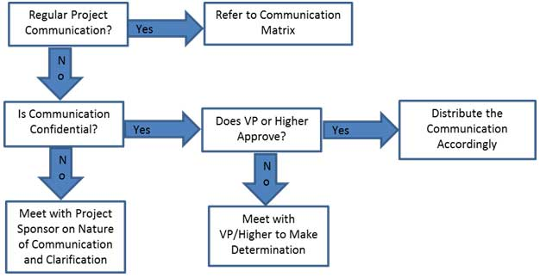

## **7.3 Guidelines for Meetings**

**Meeting Agenda**

Meeting Agenda will be distributed 5 business days in advance of the meeting. The Agenda should identify the presenter for each topic along with a time limit for that topic. The first item in the agenda should be a review of action items from the previous meeting.

**Meeting Minutes**

Meeting minutes will be distributed within 2 business days following the meeting. Meeting minutes will include the status of all items from the agenda along with new action items and the Parking Lot list.

**Action Items**

Action Items are recorded in both the meeting agenda and minutes. Action items will include both the action item along with the owner of the action item. Meetings will start with a review of the status of all action items from previous meetings and end with a review of all new action items resulting from the meeting. The review of the new action items will include identifying the owner for each action item.

**Meeting Chair Person**

The Chair Person is responsible for distributing the meeting agenda, facilitating the meeting and distributing the meeting minutes. The Chair Person will ensure that the meeting starts and ends on time and that all presenters adhere to their allocated time frames.

**Note Taker**

The Note Taker is responsible for documenting the status of all meeting items, maintaining a Parking Lot item list and taking notes of anything else of importance during the meeting. The Note Taker will give a copy of their notes to the Chair Person at the end of the meeting as the Chair Person will use the notes to create the Meeting Minutes.

**Time Keeper**

The Time Keeper is responsible for helping the facilitator adhere to the time limits set in the meeting agenda. The Time Keeper will let the presenter know when they are approaching the end of their allocated time. Typically a quick hand signal to the presenter indicating how many minutes remain for the topic is sufficient.

**Parking Lot**

The Parking Lot is a tool used by the facilitator to record and defer items which aren’t on the meeting agenda; however, merit further discussion at a later time or through another forum.

A parking lot record should identify an owner for the item as that person will be responsible for ensuring follow-up. The Parking Lot list is to be included in the meeting minutes.

## **7.4 Communications Standards**

For this project, A.I. Sports will utilize standard organizational formats and templates for all formal project communications. Formal project communications are detailed in the project’s communication matrix and include:

Kickoff Meeting – project team will utilize A.I. Sports’ standard templates for meeting agenda and meeting minutes. Additionally, any slides presented will use the A.I. Sports’ standard slideshow template.

Project Team Meetings – project team will utilize A.I. Sports’ standard templates for meeting agenda and meeting minutes. Additionally, any slides presented will use the A.I. Sports’ standard slideshow template.

Technical Design Meetings - project team will utilize A.I. Sports’ standard templates for meeting agenda and meeting minutes. Additionally, any slides presented will use the A.I. Sports’ standard slideshow template.

Monthly Project Status Meetings - project team will utilize A.I. Sports’ standard templates for meeting agenda and meeting minutes. Additionally, any slides presented will use the A.I. Sports’ standard slideshow template.

Project Status Reports – project team will utilize A.I. Sports’ standard templates for meeting agenda and meeting minutes. Additionally the standard project status report document, available on the share drive, will be used to provide project status.

Informal project communications should be professional and effective but there is no standard template or format that must be used.

## **7.5 Communication Escalation Process**

Efficient and timely communication is the key to successful project completion. As such, it is imperative that any disputes, conflicts, or discrepancies regarding project communications are resolved in a way that is conducive to maintaining the project schedule, ensuring the correct communications are distributed, and preventing any ongoing difficulties. In order to ensure projects stay on schedule and issues are resolved, A.I. Sports will use its standard escalation model to provide a framework for escalating communication issues. The table below defines the priority levels, decision authorities, and timeframes for resolution.

|  |  |  |  |
| --- | --- | --- | --- |
| **Priority** | **Definition** | **Decision Authority** | **Timeframe for Resolution** |
| Priority 1 | Major impact to project or business operations. If not resolved quickly there will be a significant adverse impact to revenue and/or schedule. | Vice President or higher | Within 4 hours |
| Priority 2 | Medium impact to project or business operations which may result in some adverse impact to revenue and/or schedule. | Project Sponsor | Within one business day |
| Priority 3 | Slight impact which may cause some minor scheduling difficulties with the project but no impact to business operations or revenue. | Project Manager | Within two business days |
| Priority 4 | Insignificant impact to project but there may be a better solution. | Project Manager | Work continues and any recommendations are submitted via the project change control process |

** NOTE: Any communication including sensitive and/or confidential information will require escalation to VP level or higher for approval prior to external distribution.

## **7.6 Glossary of Communication Terminology**

|  |  |
| --- | --- |
| Term | Definition |
| Communication | The effective sending and receiving of information. Ideally, the information received should match the information sent. It is the responsibility of the sender to ensure this takes place. |
| Stakeholder | Individuals or groups involved in the project or whose interests may be affected by the project’s execution or outcome. |
| Communications Management Plan | Portion of the overall Project Management Plan which details how project communications will be conducted, who will participate in communications, frequency of communications, and methods of communications. |
| Escalation | The process which details how conflicts and issues will be passed up the management chain for resolution as well as the timeframe to achieve resolution. |

# 8. Sponsor Acceptance

Approved by the Project Sponsor:

Date:

Patrick Wolande

Chief Financial Officer

# Appendix C. Scope Management Plan

**Scope Management Plan**

**A.I. SPORTS IPHONE APPLICATION PROJECT**



**A.I. Sports**

**1136 E. Harmony Ave**

**Mesa, AZ 85204**

**7/07/2019**

**Table of Contents**

Appendix C. Scope Management Plan 83

1. Introduction 85

2. Scope Management Approach 86

3. Roles and Responsibilities 86

Table 3.1 Scope Management Roles and Responsibilities 87

4. Scope Definition 88

5. Project Scope Statement 88

6. Work Breakdown Structure (WBS) 89

6.1 WBS Diagram 90

Figure 6.1 Work Breakdown Structure (WBS) 90

6.2 Work Breakdown Dictionary (WBD) (Placeholder) 90

Table 6.2 Work Breakdown Dictionary (WBD) 91

7. Scope Verification 91

8. Scope Control 91

9. Sponsor Acceptance 93

# 1. Introduction

The Scope Management Plan provides the scope framework for the iPhone Application Project. This plan documents several aspects of the project.

1. The scope management approach
2. Roles and responsibilities as they pertain to project scope
3. Scope definition
4. Verification and control measures
5. Scope change control
6. Project’s work breakdown structure

Any project communication which pertains to the project’s scope should adhere to the Scope Management Plan.

This project is for designing, programming, and testing a new iPhone Application that will be used to provide real-time sports investment advice and predictions on sporting events with their associated win probabilities to A.I. Sports’ partners, investors, and clients. This iPhone application can be productized to a wider audience to provide another source of revenue. This project includes the complete design of the application, all programming and coding, predictive algorithms, and testing/validation of the application. The project will include three external resources

* A lawyer, Branden Baltich, will be on retainer and serve as a consultant to ensure the iPhone Application Project abides by all legal requirements. The sport’s gambling/investing industry is still operating in a pseudo-gray area in the United States and legal counsel will be needed as this iPhone application will be available to clients in states where sports gambling is still illegal.
* Content editing for the iPhone Application Project will be outsourced to Scott Hakim.
* An external Data Scientist, Ian Shephard, will be used to help create a web scraper. This project requires an automated data pipeline from various public websites to our internal database. The data needs to be cleaned and processed before placement into our database and this resource will be able to solve our need.

No other external resources or outsourcing are anticipated for the completion of this project.

# 2. Scope Management Approach

For this project, scope management will be the sole responsibility of the Project Manager. The scope for this project is defined by the Scope Statement, Work Breakdown Structure (WBS) and WBS Dictionary. The Project Manager, Sponsor and Stakeholders will establish and approve documentation for measuring project scope which includes deliverable quality checklists and work performance measurements.

Proposed scope changes may be initiated by the Project Manager, Stakeholders or any member of the project team. All change requests will be submitted to the Project Manager, who will then evaluate the requested scope change. Upon acceptance of the scope change request, the Project Manager will submit the scope change request to the Change Control Board and Project Sponsor for acceptance. Upon approval of scope changes by the Change Control Board and Project Sponsor, the Project Manager will update all project documents and communicate the scope change to all stakeholders.

Based on feedback and input from the Project Manager and Stakeholders, the Project Sponsor is responsible for the acceptance of the final project deliverables and project scope.

# 3. Roles and Responsibilities

The Project Manager, Sponsor, and team will all play key roles in managing the scope of this project. As such, the project sponsor, manager, and team members must be aware of their responsibilities in order to ensure that work performed on the project is within the established scope throughout the entire duration of the project. The table below defines the roles and responsibilities for the scope management of this project.

|  |  |  |
| --- | --- | --- |
| **Name** | **Role** | **Responsibilities** |
| Patrick Wolande | Sponsor | * Approve or deny scope change requests as appropriate * Evaluate need for scope change requests * Accept project deliverables |
| Amanda Whiting | Project Manager | * Measure and verify project scope * Facilitate scope change requests * Facilitate impact assessments of scope change requests * Organize and facilitate scheduled change control meetings * Communicate outcomes of scope change requests * Update project documents upon approval of all scope changes |
| Jason Lee | Team Lead | * Measure and verify project scope * Validate scope change requests * Participate in impact assessments of scope change requests * Communicate outcomes of scope change requests to team * Facilitate team level change review process |
| Ian Shephard | Team Member | * Participate in defining change resolutions * Evaluate the need for scope changes and communicate them to the project manager as necessary |
| Matt Horvat | Team Member | * Participate in defining change resolutions * Evaluate the need for scope changes and communicate them to the project manager as necessary |

## **Table 3.1 Scope Management Roles and Responsibilities**

# 4. Scope Definition

The scope for this project was defined through a comprehensive requirements collection process. First, a thorough analysis was performed on the A.I. Sports’ current processes with the distribution of sports investment advice and predictions. Currently, the process to predict outcomes of sporting events and distribute predictions to our stakeholders is a very slow and manual process. Numerous investment opportunities have been missed because of the time lag. There are also many situations where betting lines and totals on games change and our predictions and associated win probabilities can change dramatically with these changes. We have to restart our entire process each time these changes occur.

From this information, the project team developed the project requirements documentation, the requirements management plan, and the requirements traceability matrix for what the new iPhone application must accomplish. The project description and deliverables were developed based on the requirements collection process and input from subject matter experts in software design, technical support, programming and business applications.

This process of expert judgment provided feedback on the most effective ways to meet the original requirements of providing a new iPhone application platform from which the company can improve its efficiency delivering accurate investment advice. The iPhone Application Project will put A.I. Sports in a league of our own, enabling our partners, investors, and clients access to our real time predictions and recommendations for every sports investment opportunity.

# 5. Project Scope Statement

The project scope statement provides a detailed description of the project, deliverables, constraints, exclusions, assumptions, and acceptance criteria. Additionally, the scope statement includes what work should not be performed in order to eliminate any implied but unnecessary work which falls outside the of the project’s scope.

This project includes the design, programming, testing, and delivery of a new iPhone application for distributing A.I. Sports’ official investment advice and prediction with their associated win probabilities for every sports investment opportunity. The deliverables for this project are a completed iPhone application with the functionality for users to have the option to manually adjust lines, teams, and “juice” for each and every sporting event. The predictive algorithm cased in the application will take these changed inputs and output the correct prediction and win probabilities in real time.

This project will be accepted once the new application has been successfully tested and produces the same results and recommendations as our in-house prediction algorithms. This project does not include ongoing operations and maintenance of the application. Only personnel and resources included in the stakeholder register may be used for this project. Additionally, the project is not to exceed 180 days in duration or $283,000 in spending. Assumptions for this project are that support will be provided by the project sponsor and all department managers and that adequate internal resources are available for the successful completion of this project.

# 6. Work Breakdown Structure (WBS)

In order to effectively manage the work required to complete this project, it will be subdivided into individual work packages which will not exceed 40 hours of work. This will allow the Project Manager to more effectively manage the project’s scope as the project team works on the tasks necessary for project completion. The project is broken down into six sections: Database, Algorithms, Application, QA (testing), Marketing, and Reporting. Each of these phases is then subdivided further down to work packages which will require no more than 40 hours of work and no less than 4 hours of work (see WBS structure below).

## **6.1 WBS Diagram**



### **Figure 6.1 Work Breakdown Structure (WBS)**

## **6.2 Work Breakdown Dictionary (WBD) (Placeholder)**

In order to more clearly define the work necessary for project completion the WBS Dictionary is used. The WBS Dictionary includes an entry for each WBS element. The WBS Dictionary includes a detailed description of work for each element and the deliverables, budget and resource needs for that element. The project team will use the WBS Dictionary as a statement of work for each WBS element.

|  |  |  |  |  |  |  |
| --- | --- | --- | --- | --- | --- | --- |
| Level | WBS Code | Element Name | Description of Work | Deliverables | Budget | Resources |
|  |  |  |  |  |  |  |
|  |  |  |  |  |  |  |
|  |  |  |  |  |  |  |
|  |  |  |  |  |  |  |
|  |  |  |  |  |  |  |

### **Table 6.2 Work Breakdown Dictionary (WBD)**

# 7. Scope Verification

As this project progresses the Project Manager will verify interim project deliverables against the original scope as defined in the scope statement, WBS, and WBS Dictionary. Once the Project Manager verifies that the scope meets the requirements defined in the project plan, the Project Manager and Sponsor will meet for formal acceptance of the deliverable. During this meeting the Project Manager will present the deliverable to the Project Sponsor for formal acceptance. The Project Sponsor will accept the deliverable by signing a project deliverable acceptance document. This will ensure that project work remains within the scope of the project on a consistent basis throughout the life of the project.

# 8. Scope Control

The Project Manager and the project team will work together to control of the scope of the project. The project team will leverage the WBS Dictionary by using it as a statement of work for each WBS element. The project team will ensure that they perform only the work described in the WBS dictionary and generate the defined deliverables for each WBS element. The Project Manager will oversee the project team and the progression of the project to ensure that this scope control process if followed.

If a change to the project scope is needed the process for recommending changes to the scope of the project must be carried out.

* Any project team member or sponsor can request changes to the project scope.
* All change requests must be submitted to the Project Manager in the form of a project change request document.
* The Project Manager will then review the suggested change to the scope of the project.
* The Project Manager will then either deny the change request if it does not apply to the intent of the project or convene a change control meeting between the project team and Sponsor to review the change request further and perform an impact assessment of the change.
* If the change request receives initial approval by the Project Manager and Sponsor, the Project Manager will then formally submit the change request to the Change Control Board.
* If the Change Control Board approves the scope change the Project Sponsor will then formally accept the change by signing the project change control document.
* Upon acceptance of the scope change by the Change Control Board and Project Sponsor the Project Manager will update all project documents and communicate the scope change to all project team members stakeholders.

# 9. Sponsor Acceptance

Approved by the Project Sponsor:

Date:

Patrick Wolande

Chief Financial Officer

# Appendix D. Schedule Management Plan

**Schedule Management Plan**

**A.I. SPORTS IPHONE APPLICATION PROJECT**



**A.I. Sports**

**1136 E. Harmony Ave**

**Mesa, AZ 85204**

**7/19/2019**

**Table of Contents**

Appendix D. Schedule Management Plan 94

1. Introduction 96

2. Schedule Management Approach 96

3. Schedule Control 97

4. Schedule Changes and Thresholds 97

5. Scope Change 98

6. Sponsor Acceptance 99

# 1. Introduction

The project schedule is the roadmap for how the project will be executed. Schedules are an important part of any project as they provide the project team, sponsor, and stakeholders a picture of the project’s status at any given time. The purpose of the schedule management plan is to define the approach the project team will use in creating the project schedule. This plan also includes how the team will monitor the project schedule and manage changes after the baseline schedule has been approved. This includes identifying, analyzing, documenting, prioritizing, approving or rejecting, and publishing all schedule-related changes.

# 2. Schedule Management Approach

Project schedules will be created using MS Project starting with the deliverables identified in the project’s Work Breakdown Structure (WBS). Activity definition will identify the specific work packages which must be performed to complete each deliverable. Activity sequencing will be used to determine the order of work packages and assign relationships between project activities. Activity duration estimating will be used to calculate the number of work periods required to complete work packages. Resource estimating will be used to assign resources to work packages in order to complete schedule development.

Once a preliminary schedule has been developed, it will be reviewed by the project team and any resources tentatively assigned to project tasks. The project team and resources must agree to the proposed work package assignments, durations, and schedule. Once this is achieved the project sponsor will review and approve the schedule and it will then be baselined.

The following will be designated as milestones for the project schedule:

* Completion of scope statement and WBS/WBS Dictionary
* Baselined project schedule
* Approval of final project budget
* Project kick-off
* Approval of roles and responsibilities
* Requirements definition approval
* Completion of data mapping/inventory
* Project implementation
* Acceptance of final deliverables

Roles and responsibilities for schedule development are as follows:

The project manager will be responsible for facilitating work package definition, sequencing, and estimating duration and resources with the project team. The project manager will also create the project schedule using MS Project and validate the schedule with the project team, stakeholders, and the project sponsor. The project manager will obtain schedule approval from the project sponsor and baseline the schedule.

The project team is responsible for participating in work package definition, sequencing, and duration and resource estimating. The project team will also review and validate the proposed schedule and perform assigned activities once the schedule is approved.

The project sponsor will participate in reviews of the proposed schedule and approve the final schedule before it is baselined.

The project stakeholders will participate in reviews of the proposed schedule and assist in its validation.

# 3. Schedule Control

The project schedule will be reviewed and updated as necessary on a bi-weekly basis with actual start, actual finish, and completion percentages which will be provided by task owners.

The project manager is responsible for holding bi-weekly schedule updates/reviews; determining impacts of schedule variances; submitting schedule change requests; and reporting schedule status in accordance with the project’s communications plan.

The project team is responsible for participating in bi-weekly schedule updates/reviews; communicating any changes to actual start/finish dates to the project manager; and participating in schedule variance resolution activities as needed.

The project sponsor will maintain awareness of the project schedule status and review/approve any schedule change requests submitted by the project manager.

# 4. Schedule Changes and Thresholds

If any member of the project team determines that a change to the schedule is necessary, the project manager and team will meet to review and evaluate the change. The project manager and project team must determine which tasks will be impacted, variance as a result of the potential change, and any alternatives or variance resolution activities they may employ to see how they would affect the scope, schedule, and resources. If, after this evaluation is complete, the project manager determines that any change will exceed the established boundary conditions, then a schedule change request must be submitted.

Submittal of a schedule change request to the project sponsor for approval is required if either of the two following conditions is true:

* The proposed change is estimated to reduce the duration of an individual work package by 10+% or increase the duration of an individual work package by 10+%.
* The change is estimated to reduce the duration of the overall baseline schedule by 10+% or increase the duration of the overall baseline schedule by 10+%.

Any change requests that do not meet these thresholds may be submitted to the project manager for approval.

Once the change request has been reviewed and approved the project manager is responsible for adjusting the schedule and communicating all changes and impacts to the project team, project sponsor, and stakeholders. The project manager must also ensure that all change requests are archived in the project records repository.

# 5. Scope Change

Any changes in the project scope, which have been approved by the project sponsor, will require the project team to evaluate the effect of the scope change on the current schedule. If the project manager determines that the scope change will significantly affect the current project schedule, he/she may request that the schedule be re-baselined in consideration of any changes which need to be made as part of the new project scope. The project sponsor must review and approve this request before the schedule can be re-baselined.

# 6. Sponsor Acceptance

Approved by the Project Sponsor:

Date:

Patrick Wolande

Chief Financial Officer

# Appendix E. Risk Management Plan

**Risk Management Plan**

**A.I. SPORTS IPHONE APPLICATION PROJECT**



**A.I. Sports**

**1136 E. Harmony Ave**

**Mesa, AZ 85204**

**7/27/2019**

**Table of Contents**

Appendix E. Risk Management Plan 100

1. Introduction 102

2. Top Three Risks 103

3. Risk Management Approach 103

4. Risk Identification 104

5. Risk Qualification and Prioritization 105

6. Risk Monitoring 105

7. Risk Mitigation and Avoidance 106

8. Risk Register 106

8.1 Risk Register (Identification) 107

Table 8.1 Risk Register 107

9. Sponsor Acceptance 108

# 1. Introduction

This section explains why risks exist and highlights the purpose and importance of the risk management plan. It provides a general description of why risk management is essential to effectively managing a project and describes what is needed before risk management can begin.

As organizations begin new projects they begin operating in an area of uncertainty that comes along with developing new and unique products or services. By doing so, these organizations take chances which results in risk playing a significant part in any project. The purpose of the risk management plan is to establish the framework in which the project team will identify risks and develop strategies to mitigate or avoid those risks. However, before risks can be identified and managed, there are preliminary project elements which must be completed. These elements are outlined in the risk management approach.

This project is considered a medium risk project as it has an overall risk score of 24 on a scale from 0 to 100. The project risk score is the average of the risk scores of the most significant risks to this project. A risk score below 16 is low risk project, a score between 16 and 45 is a medium risk project and a score above 45 is a high risk project.

Before risk management begins it is imperative that a foundation is established for providing structured project information, thus, the following project elements were completed and defined prior to developing this Risk Management Plan:

* Define work scope, schedule, resources, and cost elements
  + Develop project WBS/WBS dictionary
  + Develop master schedule and detailed schedules
  + Estimate project cost and finalize budget
  + Identify required and available resources
  + Establish performance measurement metrics
* Define minimum and maximum baseline thresholds
  + Schedule
  + Resources
  + Cost
* Baseline reporting requirements
  + Format
  + Frequency of distribution
  + Distribution list
* Define Risk Management Roles and Responsibilities
  + Project Manager chairs the risk assessment meetings
  + Project team participates in risk assessment meetings and members serve as meeting recorder and timekeeper
  + Key stakeholders participate in risk assessment meetings
  + Project Sponsor may participate in risk assessment meetings

# 2. Top Three Risks

It is important to explicitly state the top three risks to the project in the Risk Management Plan. This will make management aware of the top risks for the project and the nature of the risks.

The top three high probability and high impact risks to this project are:

**Delay in Server Equipment**

Due to a manufacturer’s production backlog, the servers are not available for large scale application testing causing a delay in the project schedule. The project manager will mitigate this risk by using servers from the backup data center if needed.

**Fiber Optics Connection Not Completed**

Due to construction delays in installing the fiber optic cable between the data center and the headquarters facilities users will not have a high speed connection between their site and the datacenter resulting in slow responses from the application making it unusable. The Project Manager will implement a site to site broadband Ethernet radio network between the data center and headquarters facility.

**Network Operations Center (NOC) Not Appropriately Staffed**

Due to lead times associated with hiring and training additional staff, the NOC does not have the necessary staff to monitor the additional bandwidth associated with the project resulting in a delay to the project schedule. The project manager will mitigate this risk by working with the NOC to create an alternate work schedule to compensate for the staffing shortage until additional staff hiring and training is complete.

# 3. Risk Management Approach

This section provides a general description for the approach taken to identify and manage the risks associated with the project. It should be a short paragraph or two summarizing the approach to risk management on this project.

The approach we have taken to manage risks for this project included a methodical process by which the project team identified, scored, and ranked the various risks. The most likely and highest impact risks were added to the project schedule to ensure that the assigned risk managers take the necessary steps to implement the mitigation response at the appropriate time during the schedule. Risk managers will provide status updates on their assigned risks in the bi-weekly project team meetings, but only when the meetings include their risk’s planned timeframe. Upon the completion of the project, during the closing process, the project manager will analyze each risk as well as the risk management process. Based on this analysis, the project manager will identify any improvements that can be made to the risk management process for future projects. These improvements will be captured as part of the lessons learned knowledge base.

# 4. Risk Identification

This section explains the process by which the risks associated with this project were identified. It should describe the method(s) for how the project team identified risks, the format in which risks are recorded, and the forum in which this process was conducted. Typical methods of identifying risks are expert interview, review historical information from similar projects and conducting a risk assessment meeting with the project team and key stakeholders.

For this project, risk identification was conducted in the initial project risk assessment meeting. The method used by the project team to identify risks was the Crawford Slip method. The project manager chaired the risk assessment meeting and distributed notepads to each member of the team and allowed 10 minutes for all team members to record as many risks as possible.

**Expert Interview**

Two Expert Interviews were held for this project. The interviews revealed several risks which were then mitigated by making changes to the project plan. The remaining risks are included in the Risk Register.

**Risk Assessment Meeting**

A risk assessment meeting was held with key team members and stakeholders. The risks identified during this meeting were added to the project plan and Risk Register.

**Historical Review of Similar Projects**

The project team reviewed the history of similar projects in order to determine the most common risks and the strategies used to mitigate those risks.

# 5. Risk Qualification and Prioritization

Once risks are identified it is important to determine the probability and impact of each risk in order to allow the project manager to prioritize the risk avoidance and mitigation strategy. Risks which are more likely to occur and have a significant impact on the project will be the highest priority risks while those which are more unlikely or have a low impact will be a much lower priority. This is usually done with a probability – impact matrix. This section explains risks were qualified and prioritized for this project. For more information on how to qualify and prioritize risks refer to our ***Risk Assessment Meeting Guide.***

In order to determine the severity of the risks identified by the team, a probability and impact factor was assigned to each risk. This process allowed the project manager to prioritize risks based upon the effect they may have on the project. The project manager utilized a probability-impact matrix to facilitate the team in moving each risk to the appropriate place on the chart.

Once the risks were assigned a probability and impact and placed in the appropriate position on the chart, the recorder captured the finished product and the project manager moved the process on to the next step: risk mitigation/avoidance planning.

# 6. Risk Monitoring

This section should discuss how the risks in the project will be actively monitored. One effective way to monitor project risks is to add those risks with the highest scores to the project schedule with an assigned risk manager. This allows the project manager to see when these risks need to be monitored more closely and when to expect the risk manager to provide status updates at the bi-weekly project team meetings. The key to risk monitoring is to ensure that it is continuous throughout the life of the project and includes the identification of trigger conditions for each risk and thorough documentation of the process.

The most likely and greatest impact risks have been added to the project plan to ensure that they are monitored during the time the project is exposed to each risk. At the appropriate time in the project schedule a Risk Manager is assigned to each risk. During the bi-weekly project team meeting the Risk Manager for each risk will discuss the status of that risk; however, only risks which fall in the current time period will be discussed. Risk monitoring will be a continuous process throughout the life of this project. As risks approach on the project schedule the project manager will ensure that the appropriate risk manager provides the necessary status updates which include the risk status, identification of trigger conditions, and the documentation of the results of the risk response.

# 7. Risk Mitigation and Avoidance

Once risks have been qualified, the team must determine how to address those risks which have the greatest potential probability and impact on the project. This section explains the considerations which must be made and the options available to the project manager in managing these risks.

The project manager has led the project team in developing responses to each identified risk. As more risks are identified, they will be qualified and the team will develop avoidance and mitigation strategies. These risks will also be added to the Risk Register and the project plan to ensure they are monitored at the appropriate times and are responded to accordingly.

The risks for this project will be managed and controlled within the constraints of time, scope, and cost. All identified risks will be evaluated in order to determine how they affect this triple constraint. The project manager, with the assistance of the project team, will determine the best way to respond to each risk to ensure compliance with these constraints.

In extreme cases it may be necessary to allow flexibility to one of the project’s constraints. Only one of the constraints for this project allows for flexibility as a last resort. If necessary, funding may be added to the project to allow for more resources in order to meet the time (schedule) and scope constraints. Time and scope are firm constraints and allow for no flexibility. Again, the cost constraint is flexible only in extreme cases where no other risk avoidance or mitigation strategy will work.

# 8. Risk Register

The Risk Register for this project is a log of all identified risks, their probability and impact to the project, the category they belong to, mitigation strategy, and when the risk will occur. The register was created through the initial project risk management meeting led by the project manager. During this meeting, the project team identified and categorized each risk. Additionally, the team assigned each risk a score based on the probability of it occurring and the impact it could potentially have. The Risk Register also contains the mitigation strategy for each risk as well as when the risk is likely to occur.

Based on the identified risks and timeframes in the risk register, each risk has been added to the project plan. At the appropriate time in the plan—prior to when the risk is most likely to occur—the project manager will assign a risk manager to ensure adherence to the agreed upon mitigation strategy. Each risk manager will provide the status of their assigned risk at the bi-weekly project team meeting for their risk’s planned timeframe.

The Risk Register will be maintained as an appendix to this Risk Management Plan.

## **8.1 Risk Register (Identification)**





### **Table 8.1 Risk Register**

# 9. Sponsor Acceptance

Approved by the Project Sponsor:

Date:

Patrick Wolande

Chief Financial Officer

# Appendix F. Human Resource Plan

**Human Resource Plan**

**A.I. SPORTS IPHONE APPLICATION PROJECT**



**A.I. Sports**

**1136 E. Harmony Ave**

**Mesa, AZ 85204**

**8/03/2019**

**Table of Contents**

1. Introduction 111

2. Roles and Responsibilities 111

3. Project Organizational Charts 113

4. Staffing Management 114

5. Sponsor Acceptance 117

# 1. Introduction

This section explains the purpose and importance of having a human resources management plan. It should provide a general description of what the plan includes and explain how the project manager and project team can use the plan to help them manage the project effectively.

Human resources management is an important part of the Software Upgrade Project. The human resources management plan is a tool which will aid in the management of this project’s human resource activities throughout the project until closure. The human resources management plan includes:

* Roles and responsibilities of team members throughout the project
* Project organization charts
* Staffing management plan to include:
  1. How resources will be acquired
  2. Timeline for resources/skill sets
  3. Training required to develop skills
  4. How performance reviews will be conducted
  5. Recognition and rewards system

The purpose of the human resources management plan is to achieve project success by ensuring the appropriate human resources are acquired with the necessary skills, resources are trained if any gaps in skills are identified, team building strategies are clearly defines, and team activities are effectively managed.

# 2. Roles and Responsibilities

Roles and responsibilities of team members and stakeholders must be clearly defined in any project. Depending on the organizational structure, project team members may represent many different groups/departments and act in the interest of different functional managers. Additionally, team members may have varying degrees of authority and responsibility. When listing roles and responsibilities the following should be included:

* Role – description of the portion of the project for which the member is accountable
* Authority – the level at which the member may make decisions, apply project resources, or make approvals
* Responsibility – the work a team member must perform to complete assigned work activities
* Competency – the skill(s) required to complete assigned project activities

The roles and responsibilities for the Software Upgrade Project are essential to project success. All team members must clearly understand their roles and responsibilities in order to successfully perform their portion of the project. For the Software Upgrade Project the following project team roles and responsibilities have been established:

**Project Manager (PM), (1 position):** responsible for the overall success of the Software Upgrade Project. The PM must authorize and approve all project expenditures. The PM is also responsible for approving that work activities meet established acceptability criteria and fall within acceptable variances. The PM will be responsible for reporting project status in accordance with the communications management plan. The PM will evaluate the performance of all project team members and communicate their performance to functional managers. The PM is also responsible for acquiring human resources for the project through coordination with functional managers. The PM must possess the following skills: leadership/management, budgeting, scheduling, and effective communication.

**Design Engineer (DE), (2 positions):** responsible for gathering coding requirements for the Software Upgrade Project. The DEs are responsible for all upgrade design, coding, and testing of the upgraded software. The DEs will assist the implementation lead in the distribution and monitoring of the software upgrades throughout the network infrastructure. The DEs will be responsible for timely status reporting to the PM as required by the communications management plan. The DEs may not authorize any project expenditures nor allocate any resources without PM approval. DE’s performance will be managed by the PM and communicated to the Design Technology Group Manager (DE’s Functional Manager). DEs must be proficient in programming html, C++, and Java programming languages.

**Implementation Manager (IM), (1 position):** The IM is responsible for the distribution, implementation, and monitoring of the new software upgrade. The IM is responsible for working with the DEs to ensure all coding on new software conforms with organizational security regulations. The IM is responsible for coordination outage windows with each department to facilitate the rollout of the software upgrades with minimal/no disturbance to operations. The IM will report status to the PM in accordance with the project’s communications management plan. The IM’s performance will be evaluated by the PM and communicated to the IM’s functional manager (Network Manager). The IM must be proficient in managing network architecture.

**Training Lead (TL), (1 position):** The TL is responsible for training all network users on the features provided by the upgrades to the existing software. The TL will coordinate training times/locations with each department’s training advocate. The TL will provide training status to the PM in accordance with the project communications management plan.

**Functional Managers (FM), (2 positions):** While not part of the project team, functional managers are responsible for providing resources for the project in accordance with the project staffing plan. Functional managers are responsible for working with the PM to determine skill sets required and approving resource assignments. Functional managers are also responsible for conducting performance appraisals of assigned resources based, in part, on the PM’s feedback regarding project performance.

# 3. Project Organizational Charts

This section provides a graphic display of the project tasks and team members. The purpose of this is to illustrate the responsibilities of team members as they relate to the project tasks. Tools such as responsible, accountable, consult, inform (RACI) or responsibility assignment matrix (RAM) may be used to aid in communicating roles and responsibilities for the project team. Additionally, organizational or resource breakdown structures may be used to show how responsibilities are assigned by department or by type of resource respectively. It should be noted that the level of detail may vary depending on project complexity.

The following RACI chart shows the relationship between project tasks and team members. Any proposed changes to project responsibilities must be reviewed and approved by the project manager. Changes will be proposed in accordance with the project’s change control process. As changes are made all project documents will be updated and redistributed accordingly.

|  |  |  |  |  |  |  |
| --- | --- | --- | --- | --- | --- | --- |
|  | Project Manager | Design Engineers | Implementation Manager | Training Leads | Functional Managers | Department Managers |
| Requirements Gathering | A | R | R | C | C | I |
| Coding Design | A | R | C |  | C | I |
| Coding Input | A | R |  |  |  |  |
| Software Testing | A | R | C |  | I | I |
| Network Preparation | A | C | R |  | I | I |
| Implementation | A | C | R | C | C | C |
| Conduct Training | A |  |  | R | C | C |

Key:

R – Responsible for completing the work

A – Accountable for ensuring task completion/sign off

C – Consulted before any decisions are made

I – Informed of when an action/decision has been made

# 4. Staffing Management

This section contains information on several areas including: when and how human resource requirements will be acquired, the timeline for when resources are needed and may be released, training for any resources with identified gaps in skills required, how performance reviews will be performed, and the rewards and recognition system to be used. It is important to note that depending on the scope of the project there may be other items included in staffing management (government and/or regulatory compliance, organizational health and safety, etc).

**Staff Acquisition:**

For the Software Upgrade Project the project staff will consist entirely of internal resources. There will be no outsourcing/contracting performed within the scope of this project. The Project Manager will negotiate with functional and department managers in order to identify and assign resources in accordance with the project organizational structure. All resources must be approved by the appropriate functional/department manager before the resource may begin any project work. The project team will not be co-located for this project and all resources will remain in their current workspace.

**Resource Calendars:**

The Software Upgrade Project will last for five weeks. All resources are required before the project can begin. The resource histogram below illustrates that design engineers are required to perform 40 hours per week per engineer for the first three weeks of the project. Their requirements are then scaled back to 5 hours per engineer in the fourth week. After the fourth week the design engineers will be released from the project. The implementation manager will also be released from the project after week 4. The training lead will be required to perform 15 hours of work in the first week and a full 40 hours of training during week 5.



**Training:**

There is currently no training scheduled with regards to the Software Upgrade Project since the organization has adequate staff with required skill sets. However, if training requirements are identified, funding will be provided from the project reserve.

**Performance Reviews:**

The project manager will review each team member’s assigned work activities at the onset of the project and communicate all expectations of work to be performed. The project manager will then evaluate each team member throughout the project to evaluate their performance and how effectively they are completing their assigned work. Prior to releasing project resources, the project manager will meet with the appropriate functional manager and provide feedback on employee project performance. The functional managers will then perform a formal performance review on each team member.

**Recognition and Rewards:**

Although the scope of this project does not allow for ample time to provide cross-training or potential for monetary rewards there are several planned recognition and reward items for project team members.

* Upon successful completion of the Software Upgrade Project, a party will be held to celebrate the success of each team member with the team members’ families present.
* Upon successful completion of the project, any team member who satisfactorily completed all assigned work packages on time will receive a certificate of thanks from the CEO.
* Team members who successfully complete all of their assigned tasks will have their photo taken for inclusion in the company newsletter.
* The company will provide free family movie tickets for the top two performers on each project.

# 5. Sponsor Acceptance

Approved by the Project Sponsor:

Date:

Patrick Wolande

Chief Financial Officer

# Appendix G. Procurement Management Plan

**Procurement Management Plan**

**A.I. SPORTS IPHONE APPLICATION PROJECT**



**A.I. Sports**

**1136 E. Harmony Ave**

**Mesa, AZ 85204**

**8/10/2019**

**Table of Contents**

1. Introduction 120

2. Procurement Management Approach 120

3. Procurement Definition 121

4. Type of Contract to be Used 122

5. Procurement Risks 122

6. Procurement Risk Management 123

7. Cost Determination 123

8. Standardized Procurement Documentation 124

9. Procurement Constraints 125

10. Contract Approval Process 126

11. Decision Criteria 127

12. Vendor Management 127

13. Performance Metrics for Procurement Activities 128

14. Sponsor Acceptance 129

# 1. Introduction

The purpose of the Procurement Management Plan is to define the procurement requirements for the project and how it will be managed from developing procurement documentation through contract closure. The Procurement Management Plan defines the following:

* Items to be procured with justification statements and timelines
* Type of contract to be used
* Risks associated with procurement management
* How procurement risks will be mitigated through contract performance metrics, insurance, or other means
* Determining costs and if/how they’re used as evaluation criteria
* Any standardized procurement templates or documents to be used
* How multiple suppliers will be managed if applicable
* Contract approval process
* Decision criteria
* Establishing contract deliverables and deadlines
* How procurement and contracts are coordinated with project scope, budget, and schedule
* Any constraints pertaining to procurement
* Direction to sellers on baseline requirements such as contract schedules and work breakdown structures (WBSs)
* Vendor Management
* Identification of any prequalified sellers if applicable
* Performance metrics for procurement activities

This Procurement Management Plan sets the procurement framework for this project. It will serve as a guide for managing procurement throughout the life of the project and will be updated as acquisition needs change. This plan identifies and defines the items to be procured, the types of contracts to be used in support of this project, the contract approval process, and decision criteria. The importance of coordinating procurement activities, establishing firm contract deliverables, and metrics in measuring procurement activities is included. Other items included in the procurement management plan include: procurement risks and procurement risk management considerations; how costs will be determined; how standard procurement documentation will be used; and procurement constraints.

# 2. Procurement Management Approach

The Procurement Management Plan should be defined enough to clearly identify the necessary steps and responsibilities for procurement from the beginning to the end of a project. The project manager must ensure that the plan facilitates the successful completion of the project and does not become an overwhelming task in itself to manage. The project manager will work with the project team, contracts/purchasing department, and other key players to manage the procurement activities.

The Project Manager will provide oversight and management for all procurement activities under this project. The Project Manager will work with the project team to identify all items to be procured for the successful completion of the project. The Project Management Office (PMO) will then review the procurement list prior to submitting it to the contracts and purchasing department. The contracts and purchasing department will review the procurement items, determine whether it is advantageous to make or buy the items, and begin the vendor selection, purchasing and the contracting process.

# 3. Procurement Definition

The purpose of procurement definition is to describe, in specific terms, what items will be procured and under what conditions. Sometimes items which must be procured for a project can be made internally by an organization. Additionally, procurement deadlines are usually affected by the project schedule and are needed by certain times to ensure timely project completion. This section is where these items must be listed, justified, and the conditions must be set. Any important technical information should also be included. Individuals may also be listed with authority to approve purchases in addition to or in the absence of the project manager.

The following procurement items and/or services have been determined to be essential for project completion and success. The following list of items/services, justification, and timeline are pending PMO review for submission to the contracts and purchasing department:

|  |  |  |
| --- | --- | --- |
| Item/Service | Justification | Needed By |
| Item A; 3” x ¾” tool | Needed for manufacturing widget type 1; we do not make this item | 31 July 20xx |
| Item B; 4” x ½” tool | Needed for building tool type 2; we make this item but do not know the cost comparison vs. purchasing it | 15 August 20xx |
| Item C | Needed for transferring data to new operating system; we do not make this item | 1 September 20xx |

In addition to the above list of procurement items, the following individuals are authorized to approve purchases for the project team:

**Name** **Role**

John Smith Project Manager

Jane Doe Lead Engineer

Bob Jones Design Technician

# 4. Type of Contract to be Used

The purpose of this section is to describe the type of contract to be used so the contracts and purchasing department can proceed accordingly. There are many different types of contracts like firm-fixed price, time and materials (T&M), cost-reimbursable, and others. Different procurement items may also require different contract types. A well defined product may be a firm-fixed price while a product which will require a research and development effort may be a T&M contract.

All items and services to be procured for this project will be solicited under firm-fixed price contracts. The project team will work with the contracts and purchasing department to define the item types, quantities, services and required delivery dates. The contracts and purchasing department will then solicit bids from various vendors in order to procure the items within the required time frame and at a reasonable cost under the firm fixed price contract once the vendor is selected. This contract will be awarded with one base year and three option years.

# 5. Procurement Risks

The purpose of this section is to identify any potential risks associated with procurement for the project. Depending on the contract type, items or services being purchased, vendor history, or uncertainties in the project’s scope, schedule, or budget, potential risks may require more detailed planning and mitigation strategies. For instance, if an organization has a close relationship to a particular vendor but there is a chance that vendor will no longer to be able to provide goods or services needed, this represents a significant risk to the project’s procurement activities that must be managed.

All procurement activities carry some potential for risk which must be managed to ensure project success. While all risks will be managed in accordance with the project’s risk management plan, there are specific risks which pertain specifically to procurement which must be considered:

* Unrealistic schedule and cost expectations for vendors
* Manufacturing capacity capabilities of vendors
* Conflicts with current contracts and vendor relationships
* Configuration management for upgrades and improvements of purchased technology
* Potential delays in shipping and impacts on cost and schedule
* Questionable past performance for vendors
* Potential that final product does not meet required specifications

These risks are not all-inclusive and the standard risk management process of identifying, documenting, analyzing, mitigating, and managing risks will be used.

# 6. Procurement Risk Management

The purpose of this section is to describe how risks related specifically to procurement activities will be managed. All projects should have an independent and thorough risk management plan. However, much like there are risks which pertain only to procurement, there are risk management considerations which may also be unique and apply only to procurement. This may include involvement of specific personnel in managing procurement risks or obtaining approval on mitigation steps from a particular management level within the organization.

As previously stated, project risks will be managed in accordance with the project’s risk management plan. However, for risks related specifically to procurement, there must be additional consideration and involvement. Project procurement efforts involve external organizations and potentially affect current and future business relationships as well as internal supply chain and vendor management operations. Because of the sensitivity of these relationships and operations the project team will include the project sponsor and a designated representative from the contracting department in all project meetings and status reviews.

Additionally, any decisions regarding procurement actions must be approved by the project sponsor or, in his absence, the Vice President of Contracts before implementation. Any issues concerning procurement actions or any newly identified risks will immediately be communicated to the project’s contracting department point of contact as well as the project sponsor.

# 7. Cost Determination

The purpose of this section is to describe how costs will be determined and if/how they will be used as part of the selection criteria. For procurements seeking goods and/or services from an outside vendor, costs are usually provided in response to a Request for Quote (RFQ), Request for Proposal (RFP), or a Request for Bid (RFB). Vendors submit quotes, proposals, or bids which describe the costs of the good or service in detail to aid the customer in their decision making. Costs are almost always used as part of the procurement decision criteria but may be prioritized differently depending on the organization.

For this project we will issue a Request for Proposal (RFP) in order to solicit proposals from various vendors which describe how they will meet our requirements and the cost of doing so. All proposals will include vendor support for items A, B, and C (from procurement definition paragraph) as well as the base and out-year costs. The vendors will outline how the work will be accomplished, who will perform the work, vendors’ experience in providing these goods, customer testimonials, backgrounds and resumes of employees performing the work, and a line-item breakdown of all costs involved. Additionally, the vendors will be required to submit work breakdown structures (WBSs) and work schedules to show their understanding of the work to be performed and their ability to meet the project schedule.

All information must be included in each proposal as the proposals will be used as the foundation of our selection criteria. Proposals which omit solicited information or contain incomplete information will be discarded from consideration.

# 8. Standardized Procurement Documentation

The purpose of this section is to describe what standard procurement documentation will be used as part of the procurement. For large complex projects, standardization makes work across all project process areas easier to manage. When organizations utilize standard forms, templates, and formats, there is commonality across different projects as well as different groups within the organization.

The procurement management process consists of many steps as well as ongoing management of all procurement activities and contracts. In this dynamic and sensitive environment, our goal must be to simplify procurement management by all necessary means in order to facilitate successful completion of our contracts and project. To aid in simplifying these tasks, we will use standard documentation for all steps of the procurement management process. These standard documents have been developed and revised over a period of many years in an effort to continually improve procurement efforts. They provide adequate levels of detail which allows for easier comparison of proposals, more accurate pricing, more detailed responses, and more effective management of contracts and vendors.

The PMO maintains a repository on the company’s shared drive which contains standard project management and procurement documentation that will be used for this project. The following standard documents will be used for project procurement activities:

* Standard Request for Proposal Template to include
  + Background
  + Proposal process and timelines
  + Proposal guidelines
  + Proposal formats and media
  + Source selection criteria
  + Pricing forms
  + Statement of work
  + Terms and Conditions
* Internal source selection evaluation forms
* Non-disclosure agreement
* Letter of intent
* Firm fixed price contract
* Procurement audit form
* Procurement performance evaluation form
* Lessons learned form

# 9. Procurement Constraints

The purpose of this section is to describe any constraints which must be considered as part of the project’s procurement management process. These constraints may be related to schedule, cost, scope, resources, technology, or buyer/seller relationships. As constraints are identified, they must be considered every step of the way as procurement activities are planned and conducted. Every effort must be made to identify all constraints prior to any project or procurement planning as constraints identified later in the project lifecycle can significantly impact the project’s likelihood of success.

There are several constraints that must be considered as part of the project’s procurement management plan. These constraints will be included in the RFP and communicated to all vendors in order to determine their ability to operate within these constraints. These constraints apply to several areas which include schedule, cost, scope, resources, and technology:

Schedule:

* Project schedule is not flexible and the procurement activities, contract administration, and contract fulfillment must be completed within the established project schedule.

Cost:

* Project budget has contingency and management reserves built in; however, these reserves may not be applied to procurement activities. Reserves are only to be used in the event of an approved change in project scope or at management’s discretion.

Scope:

* All procurement activities and contract awards must support the approved project scope statement. Any procurement activities or contract awards which specify work which is not in direct support of the project’s scope statement will be considered out of scope and disapproved.

Resources:

* All procurement activities must be performed and managed with current personnel. No additional personnel will be hired or re-allocated to support the procurement activities on this project.

Technology:

* Parts specifications have already been determined and will be included in the statement of work as part of the RFP. While proposals may include suggested alternative material or manufacturing processes, parts specifications must match those provided in the statement of work exactly.

# 10. Contract Approval Process

The purpose of this section is to define the process through which contracts must be approved. This process may vary greatly from company to company but it is important to define the process within your organization and who is involved in the decision-making. Typically large purchases follow an established bidding process and follow a formal selection and approval process. Smaller purchases can be less formal and can be approved by the Project or Program Manager. This section should clearly identify the rules for all procurements within your organization.

The first step in the contract approval process is to determine what items or services will require procurement from outside vendors. This will be determined by conducting a cost analysis on products or services which can be provided internally and compared with purchase prices from vendors. Once cost analyses are complete and the list of items and services to be procured externally is finalized, the purchasing and contracts department will send out solicitations to outside vendors. Once solicitations are complete and proposals have been received by all vendors the approval process begins. The first step of this process is to conduct a review of all vendor proposals to determine which meet the criteria established by the project team and the purchasing and contracts department. Purchases less than $x,xxx only require the approval of the Project Manager; whereas, purchases greater than $x,xxx must be approved by the Contract Review Board. For these larger purchases the contract review board will meet to determine which contract will be accepted. The Contract Review Board consists of representatives from the project team, purchasing and contracts department, finance, and the PMO.

# 11. Decision Criteria

The purpose of this section is to define the criteria used by the contract review board to decide on what contract(s) to award. Again, these criteria may vary between organizations but must be defined as part of the Procurement Management Plan.

The criteria for the selection and award of procurement contracts under this project will be based on the following decision criteria:

* Ability of the vendor to provide all items by the required delivery date
* Quality
* Cost
* Expected delivery date
* Comparison of outsourced cost versus in-sourcing
* Past performance

These criteria will be measured by the contracts review board and/or the Project Manager. The ultimate decision will be made based on these criteria as well as available resources.

# 12. Vendor Management

The purpose of this section is to describe the roles and actions the project team and purchasing and contracts department will take to ensure that the selected vendors provide all of the products/services agreed upon and that the appropriate levels of quality are maintained.

The Project Manager is ultimately responsible for managing vendors. In order to ensure the timely delivery and high quality of products from vendors the Project Manager, or his/her designee will meet weekly with the contract and purchasing department and each vendor to discuss the progress for each procured item. The meetings can be in person or by teleconference. The purpose of these meetings will be to review all documented specifications for each product as well as to review the quality test findings. This forum will provide an opportunity to review each item’s development or the service provided in order to ensure it complies with the requirements established in the project specifications. It also serves as an opportunity to ask questions or modify contracts or requirements ahead of time in order to prevent delays in delivery and schedule. The Project Manager will be responsible for scheduling this meeting on a weekly basis until all items are delivered and are determined to be acceptable.

# 13. Performance Metrics for Procurement Activities

This section describes the metrics to be used for procurement activities associated with the project. These metrics may be used to ensure the project stays on schedule regarding procurement activities. They may also be used to compile data on the performance of various vendors in order to assist with future procurement activities’ vendor selection criteria.

While the purchasing and contracts department has their own internal metrics for procurement, the following metrics are established for vendor performance for this project’s procurement activities. Each metric is rated on a 1-3 scale as indicated below:

|  |  |  |  |  |  |  |  |
| --- | --- | --- | --- | --- | --- | --- | --- |
| Vendor | Product Quality | On Time Delivery | Documentation Quality | Development Costs | Development Time | Cost per Unit | Transactional Efficiency |
| Vendor #1 |  |  |  |  |  |  |  |
| Vendor #2 |  |  |  |  |  |  |  |

1 – Unsatisfactory

2 – Acceptable

3 - Exceptional

In addition to rating each vendor, actual values will be noted in order to build a past-performance data base for selecting vendors for future procurement activities.

# 14. Sponsor Acceptance

Approved by the Project Sponsor:

Date:

Patrick Wolande

Chief Financial Officer

# Appendix H. Cost Management Plan

**Cost Management Plan**

**A.I. SPORTS IPHONE APPLICATION PROJECT**



**A.I. Sports**

**1136 E. Harmony Ave**

**Mesa, AZ 85204**

**8/16/2019**

**Table of Contents**

Appendix H. Cost Management Plan 130

1. Introduction 132

2. Cost Management Approach 132

2.1 Cost Estimating 132

Table 2.1 Cost Estimating Worksheet 133

2.2 Cost Management Approach 133

3. Measuring Project Costs 134

4. Reporting Format 134

5. Cost Variance Response Process 134

6. Cost Change Control Process 135

7. Project Budget 135

8. Sponsor Acceptance 136

# 1. Introduction

The Project Manager will be responsible for managing and reporting on the project’s cost throughout the duration of the project. During the monthly project status meeting, the Project Manager will meet with management to present and review the project’s cost performance for the preceding month. Performance will be measured using earned value. The Project Manager is responsible for accounting for cost deviations and presenting the Project Sponsor with options for getting the project back on budget. The Project Sponsor has the authority to make changes to the project to bring it back within budget.

# 2. Cost Management Approach

## **2.1 Cost Estimating**

The Cost Management plan for the iPhone Application Project utilized a bottom-up methodology to arrive at our estimations. The project was broken down to the individual work package level to determine the labor costs and total costs needed. The estimated hours of effort needed to properly complete each package were determined by several different strategies. The majority of the work packages have been completed in past projects by these teams and historical data was used to arrive at our estimated hour. Other packages were similar to previous projects and extrapolations were used to reach these estimates. There were a small percentage of packages that were new to our team and an expert was called in to advise on those estimated hours.

The raw hour estimates for each package was then multiplied by 1.33 to reach the estimated duration for the package. This calculation was used to account for the fact that a person will only be able to dedicate roughly two-thirds of their time to this project. The estimated interruption calculation was reached by multiplying the estimated duration by 0.33. The assumption here is that unplanned interruptions or distractions account for a third of a person’s workday. The estimated duration and the estimated interruption times were added together to reach our Total Duration estimate. The calculated labor costs were then determined.



### **Table 2.1 Cost Estimating Worksheet**

## **2.2 Cost Management Approach**

Costs for this project will be managed at the fourth level of the Work Breakdown Structure (WBS). Control Accounts (CA) will be created at this level to track costs. Earned Value calculations for the CA’s will measure and manage the financial performance of the project. Although activity cost estimates are detailed in the work packages, the level of accuracy for cost management is at the fourth level of the WBS. Credit for work will be assigned at the work package level. Work started on work packages will grant that work package with 50% credit; whereas, the remaining 50% is credited upon completion of all work defined in that work package. Costs may be rounded to the nearest dollar and work hours rounded to the nearest whole hour.

Cost variances of +/- 0.1 in the cost and schedule performance indexes will change the status of the cost to cautionary; as such, those values will be changed to yellow in the project status reports. Cost variances of +/- 0.2 in the cost and schedule performance indexes will change the status of the cost to an alert stage; as such, those values will be changed to red in the project status reports. This will require corrective action from the Project Manager in order to bring the cost and/or schedule performance indexes below the alert level. Corrective actions will require a project change request and be must approved by the Project Sponsor before it can become within the scope of the project.

# 3. Measuring Project Costs

Performance of the project will be measured using Earned Value Management. The following four Earned Value metrics will be used to measure to projects cost performance:

* Schedule Variance (SV)
* Cost Variance (CV)
* Schedule Performance Index (SPI)
* Cost Performance Index (CPI)

If the Schedule Performance Index or Cost Performance Index has a variance of between 0.1 and 0.2 the Project Manager must report the reason for the exception. If the SPI or CPI has a variance of greater than 0.2 the Project Manager must report the reason for the exception and provide management a detailed corrective plan to bring the projects performance back to acceptable levels.

|  |  |  |
| --- | --- | --- |
| **Performance Measure** | **Yellow** | **Red** |
| Schedule Performance Index (SPI) | Between 0.9 and 0.8 or Between 1.1 and 1.2 | Less Than 0.8 or Greater than 1.2 |
| Cost Performance Index (CPI) | Between 0.9 and 0.8 or Between 1.1 and 1.2 | Less Than 0.8 or Greater than 1.2 |

# 4. Reporting Format

Reporting for cost management will be included in the monthly project status report. The Monthly Project Status Report will include a section labeled, “Cost Management”. This section will contain the Earned Value Metrics identified in the previous section. All cost variances outside of the thresholds identified in this Cost Management Plan will be reported on including any corrective actions which are planned. Change Requests which are triggered based upon project cost overruns will be identified and tracked in this report.

# 5. Cost Variance Response Process

The Control Thresholds for this project is a CPI or SPI of less than 0.8 or greater than 1.2. If the project reaches one of these Control Thresholds a Cost Variance Corrective Action Plan is required. The Project Manager will present the Project Sponsor with options for corrective actions within five business days from when the cost variance is first reported. Within three business days from when the Project Sponsor selects a corrective action option, the Project Manager will present the Project Sponsor with a formal Cost Variance Corrective Action Plan. The Cost Variance Corrective Action Plan will detail the actions necessary to bring the project back within budget and the means by which the effectiveness of the actions in the plan will be measured. Upon acceptance of the Cost Variance Corrective Action Plan it will become a part of the project plan and the project will be updated to reflect the corrective actions.

# 6. Cost Change Control Process

The cost change control process will follow the established project change request process. Approvals for project budget/cost changes must be approved by the project sponsor.

# 7. Project Budget

The budget for this project is detailed below. Costs for this project are presented in various categories -

Fixed Costs: $ 15,000.00

Storage Costs: $ 2,000.00

Labor Costs: $240,000.00

**Total Project Cost $257,000.00**

Management Reserve $ 10,000.00

# 8. Sponsor Acceptance

Approved by the Project Sponsor:

Date:

Patrick Wolande

Chief Financial Officer

# Appendix I. Integration Management Plan

**Integration Management Plan**

**A.I. SPORTS IPHONE APPLICATION PROJECT**



**A.I. Sports**

**1136 E. Harmony Ave**

**Mesa, AZ 85204**

**8/16/2019**

1. The knowledge area of Project Integration Management consists of the following seven processes:

**Project Integration Processes**

|  |  |  |
| --- | --- | --- |
| **Process** | **Project Phase** | **Key Deliverables** |
| Develop Project Charter | Initiating | Project Charter |
| Develop Project Management Plan | Planning | Project Management Plan |
| Direct and Manage Project Work | Execution | Deliverables |
| Monitor and Control Project Work | Monitoring and Control | Change Requests |
| Perform Integrated Change Control | Monitoring and Control | Change Requests status updates |
| Close Project or Phase | Closure | Final product |

1. A project charter
   * Formally authorizes the project.
   * Gives the objectives and business case
   * Identifies the Project Manager.
   * Generic enough not to change often.
   * Written by a Manager higher in authority than Project Manager.
   * Includes name, description, deliverables
   * A project does not start unless it has a Project charter.
2. The Inputs, Tools and Techniques and Output of Develop Project Charter process are given below.   
     
   **Develop Project Charter process**

|  |  |  |
| --- | --- | --- |
| **Inputs** | **Tools & Techniques** | **Outputs** |
| Project Statement of work | Expert judgment | Project Charter |
| Business case |  |  |
| Contract |  |  |
| Enterprise environmental factors |  |  |
| Organizational process assets |  |  |

1. During project execution the project team focuses on completing the tasks assigned. The Senior Management protects the project from changes and loss of resources. The Project Manager integrates all the pieces into the project as a whole.
2. The Inputs, Tools and Techniques, and Outputs of the Develop Project Management Plan process are given in the table below.

**Develop Project Management Plan process**

|  |  |  |
| --- | --- | --- |
| **Inputs** | **Tools & Techniques** | **Outputs** |
| Project charter | Expert judgment | Project Management Plan |
| Outputs from planning processes |  |  |
| Enterprise environmental factors |  |  |
| Organizational process assets |  |  |

1. At the end of each phase of a project, a lessons learned document must be prepared. The lessons learned document defines what was done right, wrong etc. It is required to be completed in order for the project to be completed.
2. Project Management Information System (PMIS) is a system that keeps track of status of all the project tasks. It is used to track the status of the project. The exam does not focus on any specific system (for example Microsoft Project ).
3. Project Management Plan is developed by Project Manager with inputs from the team, stakeholders and management. Project Management Plan development is iterative. A Project Management Plan is bought into, approved, realistic and formal.
4. A Project Management Plan includes -
   * Project Charter
   * Budget
   * Schedule
   * Resources
   * Scope Statement
   * WBS
   * Responsibility charts/assignments
   * Management Plans
5. A Project Management Plan consolidates other management plans. These are:
   * Scope management plan
   * Requirement management plan
   * Schedule management plan
   * Cost management plan
   * Quality management plan
   * Process improvement plan
   * Human resource plan
   * Communication management plan
   * Risk management plan
   * Procurement management plan

The Project Management Plan also includes project baselines. These are:

* + Schedule baseline
  + Cost performance baseline

and

* + Scope baseline

1. Project baseline refers to the original version of the project management plan. Once the project management plan is baselined, it may only be changed by raising a change request.
2. **Progressive Elaboration** involves the process of taking a project from concept to detailed design.
3. Kick-off meeting happens after the planning phase and before the project execution. It is typically used to communicate responsibilities of key stakeholders.
4. Direct and Manage Project Work process includes performing the work defined in the PMP to achieve project goals. The Input, Tools and Techniques and Outputs of this process are given below.   
     
   **Direct and Manage Project Work process**

|  |  |  |
| --- | --- | --- |
| **Inputs** | **Tools & Techniques** | **Outputs** |
| Project management plan | Expert judgment | Deliverables |
| Approved change requests | Project management information system | Work performance information |
| Enterprise Environmental factors |  | Change requests |
| Organizational process assets |  | Project management plan updates |
|  |  | Project document updates |

1. Monitor and Control project work process includes tracking and reviewing the progress of the project. The Input, Tools and Techniques and Outputs of this process are given below.   
     
   **Monitor and Control project work process**

|  |  |  |
| --- | --- | --- |
| **Inputs** | **Tools & Techniques** | **Outputs** |
| Project management plan | Expert judgment | Change requests |
| Performance reports |  | Project management plan updates |
| Enterprise environmental factors |  | Project document updates |
| Organizational process assets |  |  |

1. The change requests that get generated are evaluated as part of the Perform Integrated Change Control process. The change requests on the project deliverables and project artifacts are managed in this process. The Input, Tools and Techniques and Outputs of this process are given below.   
     
   **Perform Integrated Change Control process**

|  |  |  |
| --- | --- | --- |
| **Inputs** | **Tools & Techniques** | **Outputs** |
| Project management plan | Expert judgment | Change request status updates |
| Work performance information | Change control meetings | Project management plan updates |
| Change requests |  | Project document updates |
| Enterprise environmental factors |  |  |
| Organizational process assets |  |  |

1. **Change Control Board** is formed to review change requests. It is used to approve or reject change requests. After the project scope has been baselined, each requested change must go through a change control review process.
2. Project Manager needs to be proactive in looking for deviations from project plan and then take timely corrective action. After that the Project Manager needs to evaluate the effectiveness of corrective action, and measure performance of corrective action, and then determine the need for further corrective action.
3. When a change request is received, the following steps must be taken (in this order) -
   * Evaluate (assess) the impact of change to the project
   * Create alternatives including cutting other tasks, crashing, fast-tracking etc.
   * Meet with management, sponsors etc.
   * Meet with the customer if necessary
4. The Close Project or Phase is the process of formal completion of all project related activities. The Input, Tools and Techniques and Outputs of this process are given below.   
     
   **Close Project or Phase**

|  |  |  |
| --- | --- | --- |
| **Inputs** | **Tools & Techniques** | **Outputs** |
| Project management plan | Expert judgment | Final product, service or result transition |
| Accepted deliverables |  | Organizational process assets updates |
| Organizational process assets |  |  |

1. At the end of each phase of a project, a lessons learned document must be prepared. The lessons learned document defines what was done right, wrong etc. It is required to be completed in order for the project to be completed.

# Appendix J. Special Topic

**Special Topic**

**A.I. SPORTS IPHONE APPLICATION PROJECT**



**A.I. Sports**

**1136 E. Harmony Ave**

**Mesa, AZ 85204**

**8/28/2019**

**Special Topic Table of Contents**

1. Introduction 144

2. Issue/Trend 1: Change Management 144

3. Issue/Trend 2: Strategic Manager 146

5. Conclusion 147

# 1. Introduction

Project management has always been a critical organizational function. Without a project manager having the tools and skills that we have learned throughout this course, a company will struggle to reach peak effectiveness and efficiency with their projects. Of course, the project management world is not a perfect realm to be viewed through only rose-colored glasses. Many companies and employees working on the ground floor view project management as an additional roadblock slowing them down. They may not fully understand the importance of the structured processes. They may have had negative experiences with project management before. Whatever the case may be, project management triggers both negative and positive emotions from those familiar with it.

There are several new trends within project management and several key issues in the area as well. The readings that we were assigned for this assignment included nine specific topics, four issues and five trends. The four issues are leadership, risk, value, and talent management. The five trends are the fact that agile is here to stay, project managers need to be strategic managers, change management embedding needs to happen in everything, importance of proper training, and finally that project management can be found everywhere.

I will address two topics that resonate with my personal experience in the workforce and from what I have learned over the last quarter in this course. The first issue/trend revolves around change management. The second issue/trend that I will discuss comes about with the changes in the professional landscape made by organizations in recent years. This is the trend organizations have using the project manager more of a strategic manager focusing on efficiency and profits and losses (P/L) than simply just delivering projects.

# 2. Issue/Trend 1: Change Management

**Change Management**

A project is subject to change as it progresses through the entirety of the project lifecycle. It is inevitable. Planning at the onset is extremely important for the success of a project, but no matter how great those plans are there are usually bumps and issues that arise once the wheels actually hit pavement. When changes to a project are needed, a project manager needs to be able to account for each deviation from the original planned path. A project manager needs to be fully in control of the change management process.

The more that a consistent change protocol is used within an organization, the more familiar stakeholders and project team members will be with following it. From my experience, stakeholders can feel entitled to making changes to whatever they want whenever they feel like it. They also expect these changes to be implemented immediately and get frustrated if they are not. These stakeholders are not used to a change management protocol. The project manager can help manage expectations and help train the stakeholders in this regard.

There needs to be a specific documented procedure to follow if the changes are expected to be implemented into the scope of the project. In this full project management plan document, sections 10.6 and 10.7 set up a specific flow for making changes to a project. There are five points in the flow.

**Change Originates**

Whatever the issue may be, this is the starting point of needing to change the project. There could be a changed deliverable because the stakeholder’s objected changed or it could be a change needed based on a risk factor in the project.

**Change Request Submitted**

Once the need for a change occurs, there needs to be a formal request submitted to the team. Section 10.7 has a standard form to fill out. It has the key details about the changes needed and what areas will be impacted.

**Change Request Approved**

The request goes to the proper parties that were designated at the beginning of the project. They will assess the situation and review the impact the change will have on the entire project. If they deem that the change is needed, the request is approved.

**Update Plan of Record**

After the approval of the change request, the project manager will update the records and make the needed adjustments to the plan. This can come in the form of updated AON or Earned value analysis. A new timeline estimate and cost estimate will be calculated.

**Distribute for Action**

Once the plans have been updated and new estimates documented, the project manager will distribute the revised project plan. The new requirements and deliverables will be sent out to the proper parties and work will move forward.

I believe that strictly following this process will help everyone involved with the project. The project stakeholders will learn how the process works and will be more aware of the changes they suggest. Project team members will have security knowing that their project manager isn’t going to abruptly change the deliverables that they have spent significant time on. They will have more trust in the process and will have less wasted effort. It is the project managers responsibility to hold everyone accountable on this workflow and it will greatly impact the company’s bottom-line.

# 3. Issue/Trend 2: Strategic Manager

**Project Manager = Strategic Manager**

In past generations, from the research that I’ve seen and the suggested articles, it appears that the project manager role focused more heavily on the deliverables. While there have been amazing project managers in the past who easily could be categorized as “strategic managers” as well, the new age of analytics and focus on “value added” is forcing current project managers to focus efforts around strategic optimization. They need to be able to navigate a typical project lifecycle with all the associated structure, timelines, and management skills, while simultaneously completing everything in the most efficient manner possible for the company as a whole.

The project manager’s role is always focused on delivering projects that have been approved within an organization over a given timeline. This is obviously the primary role of project manager. However, the industry is needing more and more project managers with the skillset to be able to see the strategic value that their projects add as a piece of the entire business operation’s initiatives. The project needs to align with key business values. The projects need to accomplish a much larger goal.

This shift comes in many ways but a key area that I have read about is that each project manager’s focus has to on more precisely accounting for the profits and losses of their projects. These financial skills have not always been a primary requirement for project managers but it appears they are needed much more often now. Deeper analysis around project impact and forecasting into the future are needed before projects are given the green light in this competitive business environment.

I believe that this trend has always been important in project management but possibly receiving more attention now. The increased amount of data points that can be accessed and used to analyze project success/efficiency shines a much larger spotlight on the topic of strategy optimization. Project managers need to know how to use numbers to be successful long term.

# 5. Conclusion

As companies are progressing in their maturity and jockeying for market share, the corporate landscape is becoming more and more competitive. Companies are investing heavily into analytics to optimize processes and gain a competitive advantage over their rivals. While big data, machine learning/artificial intelligence, and analytics dominate the headlines, project management is a critical aspect that should not be overlooked.

There will always be projects that will need to be completed until the end of time. How do companies expect to bring forward these new big data and machine learning products? The need for qualified project managers is not going away. The skills that the project managers of the future are going to need will need to adapt to meet the needs of the new market. The issues and trends of project management we read about this week will be important to remember for new and old project managers.